A Comparative Evaluation of Drought Indices Using CMIP6 Climate Model Simulations: A Case Study of Semnan Province, Iran
Ghorbani, Hossein, Mohammad Baaghideh, Alireza Entezari, Elaheh Asgari

Ghorbani, Hossein
¹Faculty of Geography and Environmental Sciences, Hakim Sabzevari University, Sabzevar, Iran.
armanneshin@gmail.com
Orcid Number: 0009-0009-3876-0009

Mohammad Baaghideh*
²Faculty of Geography and Environmental Sciences, Hakim Sabzevari University, Sabzevar, Iran.
m.baaghideh@hsu.ac.ir
Orcid Number: 0000-0002-4453-6267

Alireza Entezari
³Faculty of Geography and Environmental Sciences, Hakim Sabzevari University, Sabzevar, Iran
entezari@hsu.ac.ir
Orcid Number: 0000-0001-7093-0172

Elaheh Asgari
⁴Faculty of Geography and Environmental Sciences, Hakim Sabzevari University, Sabzevar, Iran
elaheh.asgari2011@gmail.com
Orcid Number: 0000-0003-1927-2658

*Corresponding author: Iran, Khorasan Razavi Province, Sabzevar, Hakim Sabzevari University, Geography & Environmental Sciences Faculty, Room 127.
Postal code: 9617976487, Phone: +98 (51) 44013270, Fax: +98 (51) 44013271
E-mail addresses: m.baaghideh@hsu.ac.ir

Abstract
In recent years, the world has experienced more frequent droughts, largely due to climate change. This study monitors and projects drought conditions in Semnan Province, Iran, using the Standardized Precipitation Index (SPI) and the Standardized Precipitation Evapotranspiration Index (SPEI). It also evaluates drought characteristics under future climate scenarios. Projections of temperature and precipitation from 12 CMIP6 climate models were downscaled using Quantile Mapping. To reduce uncertainty, a Bayesian Model Averaging (BMA) ensemble was created. These projections were then used to calculate 12-month SPI and SPEI values for both the baseline and near-future period (2031–2054).
Drought characteristics—such as duration, intensity, and magnitude—were analyzed using Run theory and compared across two periods. Ensemble model projections suggest that mean temperatures in the province will rise by approximately 1.1-1.2 °C relative to the baseline period under both scenarios. Furthermore, annual average precipitation is expected to increase by 3-8% at most stations in the province, except for Shahrud station. The SPI and SPEI indices exhibited a significant positive correlation, demonstrating relatively similar performance despite minor differences. Based on both indices, drought characteristics such as duration and intensity are projected to increase significantly during the latter years of the 2031–2054 horizon compared to the baseline period. The most notable increase was observed for the SPEI index under the SSP585 scenario, where drought duration rose from 6.6 months during the baseline period to 8.9 months under the SSP245 scenario and 16 months under the SSP585 scenario. For the SPI index, drought duration decreased from 6.3 months in the baseline period to 5.6 months under the SSP245 scenario, then increased to 7.8 months under the SSP585 scenario.
Keywords: Bayesian Model Averaging, Quantile Mapping, Run Theory, Semnan Province

1 Introduction

Drought is a recurring climatic anomaly characterized by a gradual onset, prolonged duration, and widespread impacts (Rahman et al., 2025; Li et al., 2021). It ranks among the most costly and least understood natural hazards, causing global economic losses of approximately USD 7.5 billion in 2020 (Zhang et al., 2023). According to the Sixth Assessment Report of the IPCC, climate change is altering precipitation and temperature patterns, increasing evapotranspiration, and accelerating soil moisture depletion. As a result, the frequency and intensity of hydrological extremes, including droughts and floods, are projected to increase (Bolan et al., 2024).
Droughts significantly affect agriculture, water resources, ecosystems, and socio-economic systems, leading to increased human migration, land degradation, overexploitation of groundwater resources, and land subsidence (Environment, 2022). Iran, located within the global arid belt and influenced by large-scale atmospheric circulation patterns and complex topography, predominantly experiences arid and semi-arid climatic conditions and frequently faces severe drought events (Asadi-RahimBeygi et al., 2025). Therefore, evaluating drought variability under current and future climate scenarios is essential for effective risk mitigation and sustainable water resource management.
Numerous indices have been developed to quantify drought, primarily based on deviations from long-term climatic averages. Among these, the Standardized Precipitation Index (SPI), introduced by McKee et al. (1993), is widely recognized as a robust tool for drought monitoring. However, its reliance solely on precipitation data limits its ability to capture temperature-driven evaporative demand. Given the critical role of evapotranspiration in drought development, indices that integrate both precipitation and atmospheric evaporative demand—such as the Standardized Precipitation-Evapotranspiration Index (SPEI), introduced by Vicente-Serrano (2010)—provide a more comprehensive assessment of drought dynamics. Rising temperatures often have a greater impact on drought intensification than decreasing precipitation, highlighting the essential role of temperature in either exacerbating or alleviating drought.
Recent research has increasingly focused on the impacts of climate change on drought occurrence, duration, and severity across various temporal and spatial scales. Many studies have utilized outputs from General Circulation Models (GCMs) within the frameworks of CMIP5 and CMIP6 under different emission scenarios to project future drought conditions. For instance, Ghazi et al. (2025) analyzed 26 CMIP6 GCMs for Poland, revealing a consistent warming trend across all scenarios, while changes in precipitation exhibited greater uncertainty. In the Yellow River Basin, China, Li et al. (2024) reported an intensification of both meteorological and agricultural droughts, with human-induced reductions in soil water-holding capacity prolonging and exacerbating agricultural droughts.
Research in Africa and the Middle East has highlighted variations in the performance of drought indices. Webne et al. (2023) found that in the Lake Tana Basin, Ethiopia, the Standardized Precipitation Index (SPI) was more effective at detecting 12-month droughts compared to the Rainfall Dependency Index (RDI) and the Standardized Drought Index (SDI). In the Aral Sea Basin, Yang et al. (2022) employed a multi-Bayesian coupling approach and projected a significant increase in multivariate drought risk from 2021 to 2050. Similarly, Gomez (2023) compared the SPI and the Standardized Precipitation Evapotranspiration Index (SPEI) in Turkey, reporting a high correlation of 0.81–0.93 between the two indices, with SPEI being approximately 15% more effective at detecting moderate to severe droughts in less arid areas. These findings emphasize the critical role of temperature and evapotranspiration in achieving a more accurate understanding of drought dynamics.
Mersa and Murphy (2023) reported that rising temperatures in Ireland, which amplify evapotranspiration, combined with declining precipitation patterns, are likely to significantly increase the frequency and severity of droughts by the end of the century. Recent studies have revealed the significant effects of climate change on drought patterns in Iran. Abdolalizadeh et al. (2023) utilized the NorESM2-MM model within the CMIP6 framework to analyze the Lake Urmia Basin. Their findings indicate that under the SSP126 scenario, moderate drought frequency is expected to increase, while severe drought events will decrease. Conversely, the SSP585 scenario predicts an overall rise in drought occurrences. On a larger scale, Ghaemi et al. (2024) used the multivariate MSPI index and CORDEX-SA regional climate models to uncover diverse drought trends across the country: northeastern regions are likely to experience reduced intensity but prolonged duration of drought, while areas in the east and southwest will see significant intensification despite shorter drought duration and frequency. Additionally, Azareh et al. (2022) confirmed that rising mean annual temperatures, coupled with decreasing precipitation, have intensified meteorological drought in Khatam City, highlighting the regional variability of climate-induced water stress.
Semnan Province, one of the driest regions in Iran, experiences the lowest precipitation among all provinces. Its extensive area, prolonged exposure to solar radiation, distance from moisture sources, and high rates of evapotranspiration contribute to chronic and severe water scarcity. In recent years, the situation has worsened due to climate change, recurring droughts, and unsustainable groundwater extraction, creating significant challenges for the province's economy, agriculture, and livestock production.
Despite many national and international studies, there is a lack of comprehensive assessments of drought in Iran's arid and semi-arid regions that simultaneously utilize precipitation-based (SPI) and precipitation-evapotranspiration-based (SPEI) indices, address uncertainties from CMIP6 models, and evaluate essential drought characteristics such as intensity, duration, and magnitude. This research gap motivates the present study, which aims to deliver an integrated and scientifically robust evaluation of drought conditions in Semnan Province. The findings will provide a solid foundation for developing effective water management strategies, climate adaptation measures, and drought mitigation policies for local decision-makers.

2 Materials and Methods
2.1 Study Area
Semnan Province covers approximately 98,000 km², positioned between longitudes 58°51' E and 58°57' E, and latitudes 31°37' N and 34°17' N. Nestled on the southern slopes of the Alborz Mountains, the province also includes part of the desert plain. It has an average elevation of 1,113 meters above sea level and is divided into three geographical regions: mountainous areas, foothills, and low desert plains. The average annual precipitation in the province is around 125.8 mm, with a mean annual temperature of 17.3°C. Figure 1 depicts the geographical location of the study area and the locations of the province's synoptic stations.

Fig 1. Location of the study area

2.2 Methodology
2.2.1 Data

For this study, we obtained daily precipitation and temperature data from the Iran Meteorological Organization for the synoptic stations of Beyarjmand, Garmsar, Semnan, and Shahrud covering the period from 1990 to 2014.
Table 1 presents the specifications of the selected stations. To examine the effects of climate change on droughts in the study area, we utilized outputs from 12 General Circulation Models (GCMs) from Phase 6 of the Coupled Model Intercomparison Project (CMIP6). Drought conditions were assessed using two scenarios: the moderate scenario (SSP245) and the pessimistic scenario (SSP585). Projections were made for the near-future 25-year period from 2031 to 2054. The outputs of the GCMs were downscaled using the Quantile Mapping method, and the accuracy of the models was evaluated using the RMSE, R², and MAE indices.

Table 1. Locations of Weather Stations and Climate Models Utilized in the Study
Data | Station | Longitude | Latitude | Elevation (m)
Observed | Beyarjmand | 55° 08ʹ | 36° 08ʹ | 1099.3
Observed | Garmsar | 52° 21ʹ | 35° 14ʹ | 899.9
Observed | Semnan | 53° 25ʹ | 35° 35ʹ | 1127
Observed | Shahrud | 54° 57 | 36° 25ʹ | 1325.2
Observed | Name | Description |  | Resolution spatial
GCMs simulated | CMCC-ESM2 | Center Euro-Mediterraneo Sui Cambiament Climatici |  | 1.875° ×1.25°
GCMs simulated | EC-Earth3-Veg-LR | The EC-Earth-Consortium team of European institutions and organizations |  | 0.7° ×0.7°
GCMs simulated | INM-CM5-0 | Institute for numerical mathematics, Russian Academy of Science/Russia |  | 1.5° ×2°
GCMs simulated | INM-CM4-8 | Institute for Numerical Mathematics, Russian Academy of Science/Russia |  | 1.5° ×2°
GCMs simulated | MRI-ESM2-0 | Meteorological Research Institute (MRI)/ Japan |  | 1.1° ×1.1°
GCMs simulated | NESM3 | NUIST Earth System Model  / China |  | 1.9° ×1.9°
GCMs simulated | MIROC6 | Institute for Environmental Studies, RIKEN Center for Computational Science  /Japan |  | 1.4° ×1.4°
GCMs simulated | CNRM-ESM2 | Centre National de Recherches Meteorologiques/France |  | 1.4° ×1.4°
GCMs simulated | ACCESS-CM2 | Australian Community Climate and Earth  System Simulator/Australian |  | 1.2° ×1.8°
GCMs simulated | FGOALS-g3 | Flexible Global Ocean‐Atmosphere‐Land System Model /China/ Beijing |  | 0.9375° ×1.25°
GCMs simulated | GFDL-ESM4 | Geophysical Fluid Dynamics Laboratory/ USA |  | 1.0° ×1.3°
GCMs simulated | MPI-ESM1-2-LR | Max Planck Institute Earth System Model  / Germany |  | 1.875° ×1.875°

2.3 Bias Correction Method and Ensemble Model Generation from GCM Outputs
Bias correction is a crucial technique for enhancing the quality of General Circulation Model (GCM) outputs by eliminating systematic errors. Various methods exist for bias correction, each with its own advantages and limitations. The effectiveness of these methods is influenced by factors such as the choice of GCMs, the study region, the season, and the specific climate variable being analyzed (Asgari et al. 2022).

2.3.1 Quantile Mapping Method
The Quantile Mapping (QM) method, introduced by Panofsky and Brier in 1968, is a widely used technique for bias correction. The QM algorithm has demonstrated superior performance compared to simpler methods that only adjust the mean or both the mean and variance of precipitation time series (Cannon et al. 2015). This method employs a transfer function to construct cumulative distribution functions (CDFs) for both model simulations and observations. This transfer function enables the transformation of raw model outputs into corrected values, ensuring that the CDF of the corrected model aligns with that of the observational dataset (Teutschbein and Seibert 2012). Mathematically, the Quantile Mapping can be implemented using the following equation:
$Y=F_{obs}^{-1}(F_{GCM}(x))$ (1)
In this context, Y represents the corrected value, while x is the value that needs correction. In addition, $F_{obs}^{-1}$denotes the inverse of the observational CDF, while $F_{GCM}$represents the CDF of the GCM used.
2.3.2 Bayesian Method Averaging
Bayesian model averaging is a technique used to combine forecasts from various models, resulting in a new probability density function (PDF) that predicts the desired climate variable for the upcoming period. The output of BMA is a weighted average of the probability density functions (PDFs) centered on the bias-corrected forecasts. The weights assigned by BMA indicate the relative contribution of each model component in predicting the training samples, allowing for an assessment of the usefulness of each ensemble member. For a variable y that must be predicted based on the training data $y^{T}$using K models $M_{1},…,M_{K}$, the predictive PDF $P(y∣y^{T})$can be expressed as follows (Wang et al., 2018):
$P\left(y | y^{T}\right)=\sum_{K=1}^{K}{P\left(y | M_{k}y^{T}\right)}P\left(M_{k} | y^{T}\right)$ (2)
In this equation, $P(y∣M_{k},y^{T})$is the predictive PDF based on model $M_{k}$; $K$is the number of models; and $P(M_{k}∣y^{T})$is the posterior probability that model $M_{k}$is correct given the training data, indicating how well model $M_{k}$represents the training data. The sum of the posterior model probabilities is equal to one, i.e., $\sum_{k=1}^{K}{P(}M_{k}∣y^{T})=1$. Therefore, they can be considered as weights. In the study by Raftery et al. (2005), more detailed information about the BMA model is provided, and the method for estimating the weight of each model $M_{k}$in BMA is described. In the present study, the Standardized Precipitation Index (SPI) and the Standardized Precipitation Evapotranspiration Index (SPEI) were used to monitor and forecast drought in Semnan Province.

2.4 Standardized Precipitation Evapotranspiration Index (SPEI)
The Standardized Precipitation Evapotranspiration Index was first introduced by Vicente-Serrano et al. (2010). The advantage of this multivariable index compared to the SPI is that it accounts for the effect of evapotranspiration on drought. In the SPEI index, the values of the difference between precipitation and potential evapotranspiration (PET), based on the climatic water balance, are used. This index is obtained using the following equations:
$\text{PET}=16K{\left(\frac{{10}^{T}}{I}\right)}^{m}$ (3)
$m=6.75×{10}^{-7}I^{3}-7.71×{10}^{-5}I^{2}+1.79×{10}^{-2}$ (4)
$i={\left(\frac{T}{5}\right)}^{1.514}$ (5)
$K=\left(\frac{N}{12}\right)\left(\frac{NDM}{31}\right)$ (6)
In these equations, $T$ represents the mean monthly temperature in degrees Celsius; $m$is a coefficient dependent on $I$; $I$ is the thermal index, or the annual sum of the 12 monthly $i$ values; $K$ is a correction factor based on the month and latitude; $NDM$ is the number of days in a month; and $N$ is the maximum possible sunshine duration in hours.
Accordingly, once the potential evapotranspiration is determined, the difference between precipitation $P$ and $PET$ for the i-th month can be calculated.
$D_{i}=R_{i}-{PET}_{i}$ (7)
Since the values of $D_{i}$ range from the lower bound to negative values, two‑parameter probability functions are not suitable for this purpose. Vicente‑Serrano et al. (2010) examined various three‑parameter functions and found that the three‑parameter log‑logistic probability density function provides the best fit for these values. The general form of the probability density function of this distribution is presented in Equation (8).
$f\left(x\right)=\frac{β}{α}({\frac{x-γ}{α})}^{β-1}{\left\lceil (1+({\frac{x-γ}{α})}^{β})\right\rceil }^{-2}$ (8)
In this equation, the parameters $α$, $β$, and $γ$ represent the scale, shape, and location, respectively, for the values of $D_{i}$ within the range $γ<D<∞$. The probability distribution function of the D series is calculated using Equation (9):
${F\left(X\right)=\left\lceil (1+({\frac{α}{x-γ})}^{β})\right\rceil }^{-1}$ (9)
The SPEI index can easily calculate the standardized values of $F(X)$.
$SPEI=W-\frac{C_{0}+C_{1}W+C_{2}W^{2}}{1+d_{1}W+d_{2}w^{2}+d_{3}w^{3}}$ (10)
In this equation, $W=\sqrt{-2ln⁡(p)}$for $P≤0.5$, where $P$represents the probability of exceeding the specified values of $D$. The coefficients $C_{0}$, $C_{1}$, $C_{2}$, as well as $d_{1}$, $d_{2}$, and $d_{3}$, are constants.
The standardized index can be compared with other SPEI values across different locations and time periods. An SPEI value of zero corresponds to a cumulative probability of 50% for $D$(Vicente-Serrano et al., 2010).
2.5 Standardized Precipitation Index (SPI)
The Standardized Precipitation Index (SPI), developed by McKee et al. (1993), is a tool for identifying and monitoring droughts and their intensity over various time scales. It functions as a Z-score, indicating how much an event deviates from the average, measured in standard deviation units. This characteristic enables the comparison of SPI values across different locations and time periods. A drought event is deemed to occur when the index values drop below −1, and it concludes when the values become positive again. The index is calculated using the following equation:
$SPI=\frac{X_{i}-\overline{x}}{δ}$ (11)
Where SPI is the standardized precipitation index for a given period, $X_{i}$ represents precipitation, $\overline{x}$ is the mean precipitation, and $δ$ denotes the standard deviation of precipitation. The classification of the two indices mentioned above is presented in Table 2.
Table 2. Classification scale of SPEI and SPI Drought Indices
Drought/Wetness Class | Index Value
Extremely wet | ≥ 2
Very wet | 1.5 to 1.99
Moderately wet | 1.0 to 1.49
Near normal | -0.99 to 0.99
Moderate drought | -1.0 to -1.49
Severe drought | -1.5 to -1.99
Extreme drought | ≤ -2

2.6 Drought Characteristics (Run Theory)
One widely used method for analyzing drought is the Run Theory. This approach defines three key characteristics of drought: duration, severity, and intensity. In this study, we assessed these characteristics by calculating the Standardized Precipitation Index (SPI) and the Standardized Precipitation Evapotranspiration Index (SPEI) on a monthly basis for both current and future periods. According to this method, the duration of a drought period is determined by the sequence of negative values (Drought Duration). Drought severity (Severity, D) is measured by the sum of negative deviations within each sequence, while drought intensity reflects the average precipitation deficit during a specific drought period (Guerrero-Salazar, & Yevjevich ,1975).
2.7 Wavelet Coherence
The concept of wavelet coherence in signal processing focuses on measuring the relationship between two signals or their representations. When examining two continuous signals with finite energy, $x(t)$ and $y(t)$, the classical cross-correlation can be considered as the relationship between these signals. By examining the Fourier transform of the signals, the spectral correlation of the signals $x(t)$and $y(t)$is defined according to relation (12):
$p\left(f\right)=\frac{S_{xy}(f)}{\sqrt{|S_{xx}(f)S_{yy}(f)}}$ (12)
Here, $S_{xy}(f)$represents the cross-spectral density between the two signals $x(t)$and $y(t)$. It is defined under the assumption of stationarity in the cross Fourier spectrum.
$S_{xy}=\int_{∞}^{+∞}{R_{xy}\left(τ\right)\exp\left(-i2πfτ\right)dτ }$ (13)
$p(f)$takes a value between zero and one. If $p(f)$is close to one for every frequency, then $y(t)$can be approximated as a linear time-invariant function of $x(t)$. In climatological and hydrological time series, which are often non-stationary, it has been suggested to use time-frequency representations of the signals. The coherence analysis reveals the temporal variations in the relationship between the two signals and allows for the identification of transitional covariance values. To address the challenges posed by non-stationary signals, wavelet coherence has been introduced. A key issue arises when applying analog formulas to equation (13), resulting in a coherence value of one at all times, despite the absence of a genuine relationship between the signals. To mitigate this problem, efforts have been made to utilize a smoothed estimate of the wavelet spectrum, leading to the recommendation of wavelet coherence. The definitions for the smoothed wavelet spectrum and the smoothed cross-spectrum are provided in relations (14) and (15).
${Sw}_{xy}(a,τ)=\int_{t-\frac{δ}{2}}^{t+\frac{δ}{2}}{W_{xx}^{*}\left(a,τ\right)W_{xx}\left(a,τ\right)dadτ}$ (14)
${Sw}_{xy}(a,τ)=\int_{t-\frac{δ}{2}}^{t+\frac{δ}{2}}{W_{xx}^{*}\left(a,τ\right)W_{yy}\left(a,τ\right)dadτ}$ (15)
In these relationships, the scalar indicates the size of the two-dimensional smoothing filter (Latabaccher et al., 2001). This is a crucial parameter for wavelet coherence, and it must be sufficiently large to yield an accurate estimate. Consequently, the Fourier coherence is defined as follows:
$Wc\left(a,τ\right)=\frac{|{SW}_{xy}(a,τ)}{\sqrt{[\left|W_{xx}\left(a,τ\right)\right|\left|W_{yy}\left(a,τ\right)\right|]}}$ (16)
$W_{c}$takes a value between zero and one. Wavelet coherence, by identifying existing periodicities, can provide a comparison between phenomena and reveal the relationships between them. In climatological studies focused on identifying similar structures within time series, the Morlet mother wavelet is commonly employed for time-frequency analysis (Mirzayi Hasanlo et al., 2020). This study utilized continuous wavelet analysis to assess the coherence between the two indices, SPI and SPEI.

3 Results
3.1 Validation of CMIP6 models
We evaluated projected precipitation and temperature data from 12 general circulation models (GCMs) and an ensemble model, comparing them to observational data from four synoptic stations in Semnan Province for the period from 1990 to 2014. The results of this comparison are illustrated in Figure 2. Our findings indicate that the climate models predict temperature more accurately than precipitation, as shown by the statistical indices RMSE, MAD, and R². This discrepancy is likely due to the inherently variable nature of precipitation. The validation of the ensemble output generated using the Bayesian Model Averaging (BMA) method for both parameters (Fig. 2) revealed a significant reduction in error magnitude, particularly for precipitation, as indicated by the RMSE and MAD indices. Consequently, all subsequent analyses related to drought monitoring and projections in the study area will rely on the BMA ensemble model. The results demonstrate that the ensemble implementation of GCMs outperforms individual models.
Following the selection of the ensemble model, projected future temperature and precipitation data for the near-future period (2031–2054) were analyzed under the SSP245 and SSP585 scenarios. Table 3 presents the percentage changes in temperature and precipitation for Semnan Province during this period. The table indicates that the projected mean temperature at all studied stations is expected to rise in the coming decades under both scenarios, with the most significant increase occurring in the pessimistic SSP585 scenario. The average temperature increases across the province range from approximately 1.1 to 1.5 °C under the intermediate SSP245 scenario and from 1.21 to 2.12 °C under the SSP585 scenario.
Table 3 shows that the spatial patterns of annual precipitation changes across the studied stations exhibit significant variability in response to different climate scenarios. Most stations in Semnan Province are projected to experience an increase in total annual precipitation in the future, suggesting a potential improvement in moisture conditions in certain areas of the province. In contrast, Shahrud station, which has a baseline precipitation of 175.2 mm, is expected to follow a different trend. It is forecasted to see a decrease in annual precipitation under both the SSP245 and SSP585 scenarios, with estimated reductions of approximately 11.8% and 9.9%, respectively.

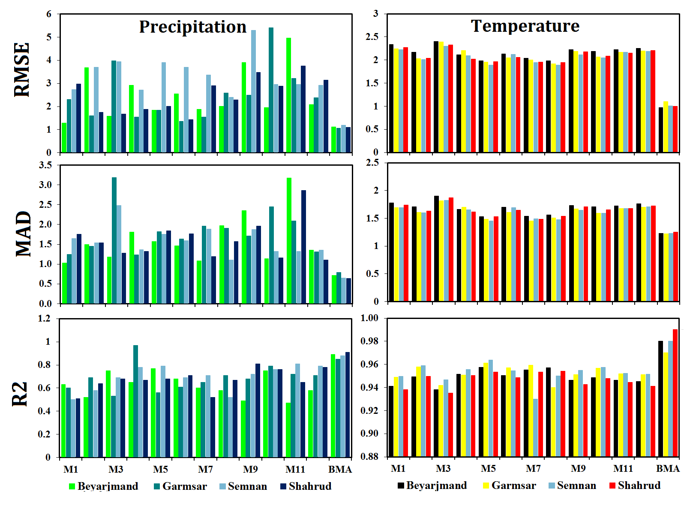
Fig. 2. Statistical evaluation of error correction: Individual CMIP6 models vs. BMA ensemble for precipitation and temperature.
Table 3. Percentage changes in temperature and precipitation in Semnan Province under future climate conditions
station | Baseline Mean Temperature (°C) | Mean Temperature (°C) |  | Baseline Precipitation  (mm) | Precipitation Change (%)
station | Baseline Mean Temperature (°C) | SSP245 | SSP585 | Baseline Precipitation  (mm) | SSP245 | SSP585
station | Baseline Mean Temperature (°C) | (2040s) |  | Baseline Precipitation  (mm) | (2040s)
Beyarjmand | 16.1 | 1.2 | 1.4 | 125.7 | 6.1 | 8
Garmsar | 18.9 | 1.1 | 1.2 | 117.2 | 3.7 | 5.3
Semnan | 18.5 | 1.1 | 1.3 | 140.3 | 3.2 | 3
Shahrud | 15.4 | 1.5 | 2.1 | 175.2 | -11.8 | -9.9
3.2 Assessment of SPI and SPEI Drought Indices under Historical and Future Climate Conditions
To investigate variations in the intensity and persistence of dry and wet periods, the drought indices SPI and SPEI were computed and analyzed at a 12-month timescale for the synoptic stations of Beyarjmand, Garmsar, Semnan, and Shahrud during the observational period from 1990 to 2014. Figure 3 illustrates the temporal evolution of these indices across the studied stations.
The results from both indices reveal a recurrent alternation of drought and wet conditions across the region. However, noticeable differences in the intensity, duration, and occurrence of these periods are observed among the stations and between the two indices, indicating considerable spatial heterogeneity and contrasting sensitivities of SPI and SPEI to climatic drivers.
According to the SPEI index, the water balance at all investigated stations was predominantly positive during the period from 1990 to 1997, with index values exceeding +1 in several years, reflecting pronounced wet conditions at the provincial scale. The concurrence of this interval with the positive phase of the North Atlantic Oscillation (NAO), as documented in previous studies (Yousefizadeh and Jalali, 2014), suggests the influence of large-scale atmospheric circulation patterns in enhancing regional moisture availability.
During the period from 1998 to 2002, the SPEI indicates the occurrence of moderate drought conditions at the Semnan and Beyarjmand stations. This interval was associated with the strong El Niño event of 1997–1998, which, according to national reports, resulted in substantial reductions in surface and groundwater resources and a marked decline in agricultural production across extensive parts of Iran (Zareabyaneh et al., 2015). In contrast, the Garmsar and Shahrud stations largely remained under near-normal conditions, underscoring the differential climatic responses of the stations to synoptic-scale variability. The temporal analysis of the SPEI index shows that the Garmsar station faced primarily moderate to severe drought conditions from 2006 to 2014, with the exception of 2012. A similar trend was observed at the Semnan station from 2007 to the end of the study period, although two brief wet episodes in 2010 and 2012 temporarily alleviated the drought conditions. In contrast, the Shahrud station experienced relatively wetter conditions, remaining mostly within the normal to wet range except for 2008.
The analysis of the SPI index reveals a similar alternating pattern of dry and wet periods across the region. The results indicate a relatively prolonged wet period between 2006 and 2009 at all stations, with 2008 experiencing the highest intensity. Temporal analysis of the SPI series shows that drought events at the Beyarjmand, Garmsar, and Semnan stations occurred almost synchronously, with the most severe drought recorded in 1998, when the index reached approximately −2.5. In contrast, the Shahrud station predominantly experienced normal to wet conditions during the 1990–2014 period based on the SPI index.

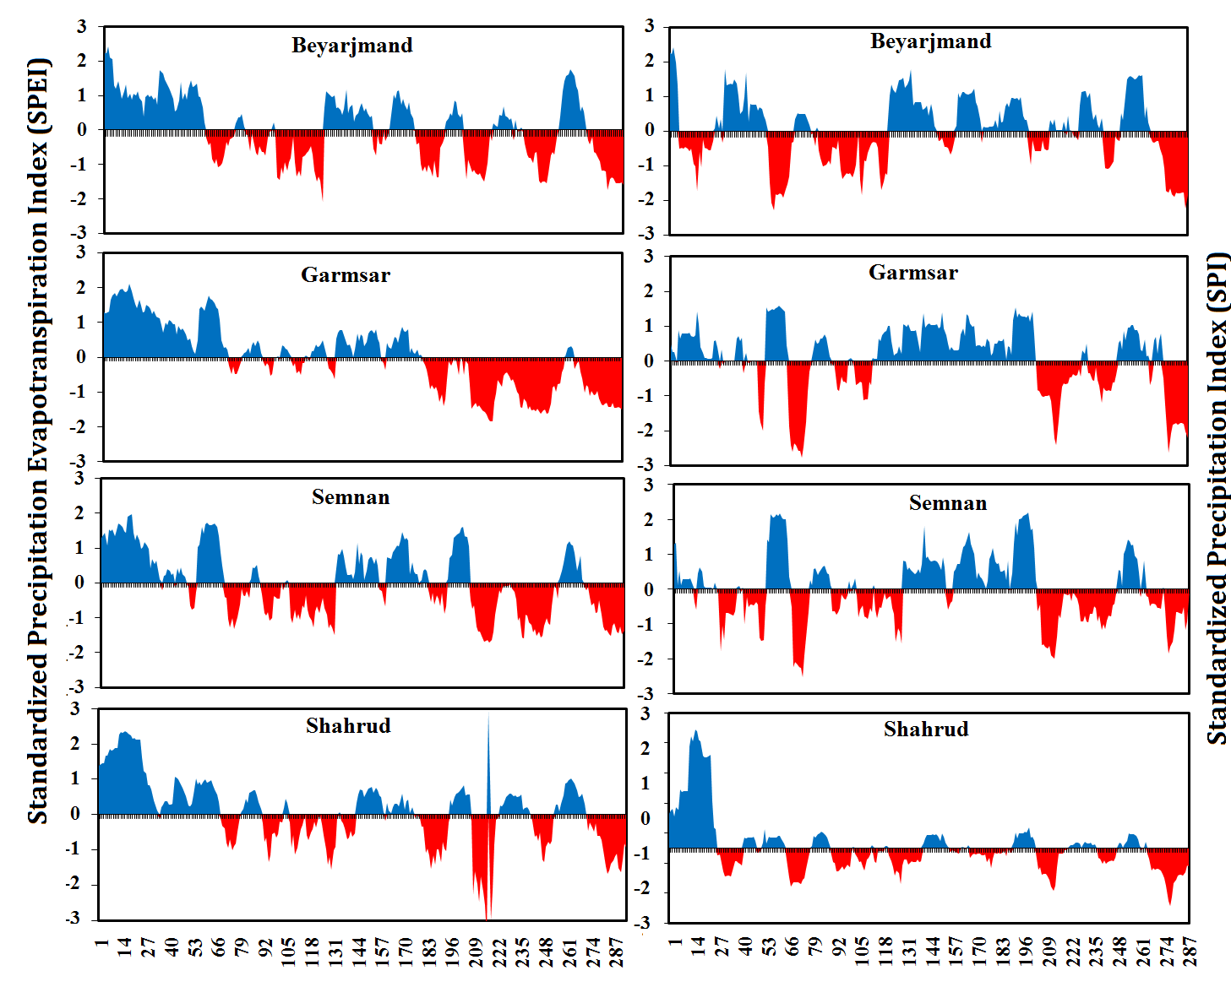

Fig 3. Dry and wet period variations based on SPI and SPEI (1990–2014)
Figure 4 presents the status of drought indices under the SSP245 scenario for the near-future period. According to the SPEI index, the studied stations are projected to experience conditions ranging from near-normal to severe wetness during the 2030–2045 interval, with peak intensity occurring at the beginning of this period. However, starting in 2046, drought conditions are projected to prevail across the region, resulting in a widespread impact of this hazard throughout the province. By the mid-2050s, SPEI values at all stations are projected to drop below −2, signaling the most severe droughts experienced in the past fifty years. In contrast, the SPI index shows more variability during this timeframe, with the selected stations experiencing alternating periods of wet, normal, and dry conditions.
Despite minor differences between the two analyzed indices, the SPI, like the standardized evapotranspiration index (SPEI), indicates wet conditions at the beginning of the study period, followed by alternating phases of drought and wetness toward the end. While the observed differences are not particularly significant, they can be attributed to the lack of influence from the temperature parameter, which, according to previous results, shows a more pronounced increasing trend under future climatic conditions.

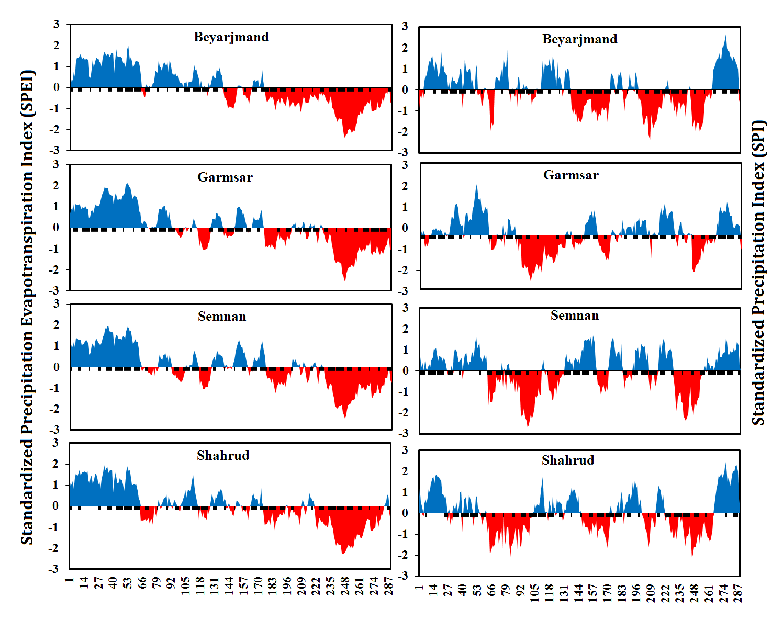

Fig 4. Variations in dry and wet periods based on the SPI and SPEI indices under the SSP245 scenario

The anticipated increase in future precipitation, especially in extreme daily rainfall, is more pronounced in precipitation-driven phenomena. This trend is evident in both analyzed indices under the pessimistic SSP585 scenario throughout the study area. Despite the significant rise in temperature under this scenario, the highly variable and uncertain precipitation trends have caused the drought indices to shift toward lower values in the graphs. This creates the misleading impression of reduced severity of the phenomenon. The maximum SPEI value in this scenario is −1.95, observed in 2048 at the Biarjmand station, while the other stations do not reach −2. In contrast, under the SSP245 scenario, drought intensity varies from −2.28 to −2.54 across the selected stations. Despite these differences in drought severity, the frequency of wet and dry periods remains similar in both scenarios. The study area is projected to experience more severe drought conditions uniformly in the final years of the 2031–2054 period (Fig 5).
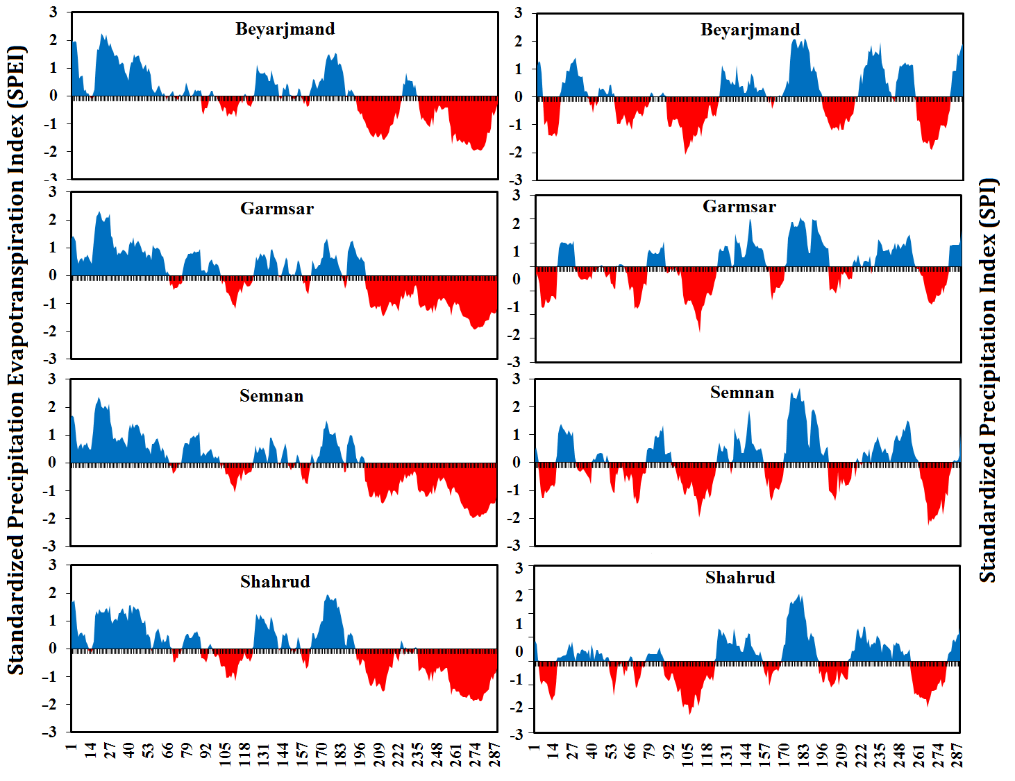
Fig 5. Variations in dry and wet periods based on the SPI and SPEI indices under the SSP585 scenario

3.3 Continuous Wavelet Analysis
Wavelet coherence analysis is employed to evaluate the correlation between two variables. The resulting diagram features three main components: scale, time, and correlation. The scale (or time scale) is represented on the vertical axis, while time is displayed on the horizontal axis. The strength of the correlation is indicated by a vertical color bar alongside the diagram. Directional arrows within the figure illustrate the phase difference between the two variables. Generally, arrows pointing to the right suggest that the variables are in phase, while arrows pointing to the left indicate they are in anti-phase. Arrows directed right and downward or left and upward imply that the first variable leads the second. Conversely, arrows pointing right and upward or left and downward suggest that the second variable leads the first. Since the SPI and SPEI indices use the same qualitative classification scheme, their values can be compared through correlation analysis. In this study, the cross-wavelet transform (XWT) algorithm was utilized to assess whether a statistically significant relationship exists between the SPI and SPEI indices at the 95% confidence level. The cross-wavelet analysis reveals the distribution of covariance between these indices across various time scales.
The correlation results between the two indices for the study area, presented in Figure 6, reveal a significant correlation at the Beyarjmand station during the baseline period from 1991 to 2008 at the 16–32 month time scale. Additionally, a correlation is noted at the 2–8 month scale during the years 1993–2004, 2008, and 2011, with the direction of the arrows indicating a positive correlation.
For the Garmsar station, the data show a statistically significant positive correlation at the 95% confidence level from 1991 to 2006 at the 16–32 month time scale, continuing consistently from 2007 to 2014 at the 32-month scale. Furthermore, intermittent yet significant correlations are observed at this station during the 2–8 month scale across the study years.
The findings from the wavelet transform indicate that the Semnan station exhibits the highest level of significant correlation between the SPI and SPEI indices in the province. A significant positive correlation is present from 1991 to 2014 at the long-term time scales of 16–64 months, as well as at the 2–8 month scale during most of the study years.
Analysis of the wavelet results for the Shahrud station shows a positive and significant correlation at the 16–64 month time scale during the 1993–2011 period. Additionally, a positive and statistically significant correlation is observed at the 8–16 month scale during the periods 1996–2005 and 2008–2010.
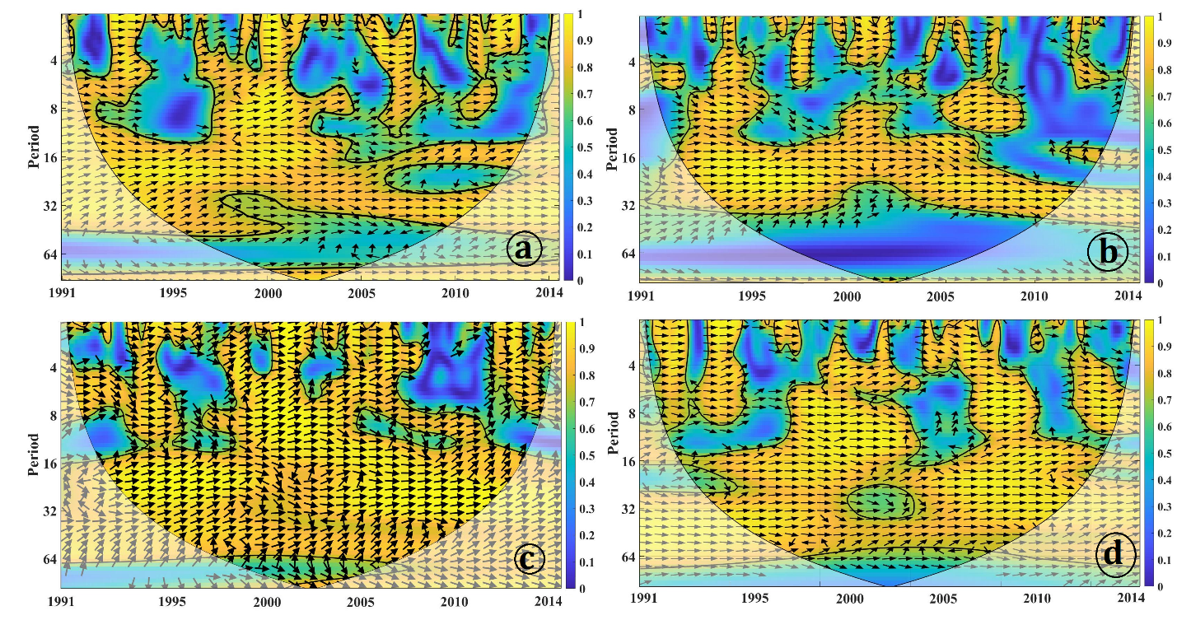

Fig. 6. Continuous wavelet analysis of the SPI and SPEI indices from 1991 to 2014: (a) Beyarjmand, (b) Garmsar, (c) Semnan, and (d) Shahrud.

3.4 Temporal variations in drought characteristics
Drought characteristics (such as severity, duration, and magnitude) were assessed using run theory with the SPI and SPEI time series for both the baseline and near-future periods under the SSP245 and SSP585 scenarios in Semnan Province. Table 3 displays the temporal changes in mean duration, severity, and magnitude of drought. Projections based on the SPEI index for the SSP245 scenario indicate that, compared to the baseline period, both the duration and severity of drought are expected to increase at all stations, while drought magnitude is projected to decrease. Under the more pessimistic SSP585 scenario, rising temperatures lead to significant differences in duration and severity indices relative to the 1990–2014 period. Notably, the greatest increase in drought duration occurs at the Garmsar and Shahroud stations, where it escalates from 8.7 and 4 months to 20 and 15.2 months per year, respectively, under the SSP585 scenario. Additionally, results indicate that the most severe drought, with a severity rating of 9.6, is anticipated to occur at the Shahroud station under the SSP585 scenario.
The drought characteristics derived from the SPI index, generated under Shared Socioeconomic Pathway (SSP) scenarios, show only minor differences when compared to the corresponding SPEI indices. While both indices project an increase in drought duration and severity over the coming decades, the projections from the SPI index remain lower than those from the Standardized Precipitation Evapotranspiration Index (SPEI). This discrepancy is due to the inclusion of temperature and evapotranspiration parameters in the SPEI calculation, which affects the drought characteristics. Overall, results from both indices indicate that Semnan Province is expected to face more severe and prolonged drought events in the future under both scenarios.

Table 3. Temporal Changes in Drought Characteristics During the Observational and Projected Periods
Station | Index | Baseline | SPEI |  | Baseline | SPI
Station | Index | Baseline | SSP585 | SSP245 | Baseline | SSP585 | SSP245
Station | Index | Baseline | (2040s) |  | Baseline | (2040s)
Beyarjmand | Duration | 7.7 | 7.8 | 13 | 5.8 | 5.6 | 11.7
Beyarjmand | Severity | 4.5 | 4.2 | 8.1 | 4.2 | 3.5 | 7
Beyarjmand | Magnitude | 0.5 | 0.2 | 0.4 | 0.5 | 0.4 | 0.4
Garmsar | Duration | 8.7 | 16.7 | 20 | 7.3 | 7.4 | 7.5
Garmsar | Severity | 5.1 | 5.6 | 8.6 | 4.5 | 3.4 | 4.7
Garmsar | Magnitude | 0.5 | 0.3 | 0.3 | 0.4 | 0.3 | 0.4
Semnan | Duration | 6.9 | 9.7 | 15.7 | 6.4 | 6.6 | 7.5
Semnan | Severity | 4.7 | 5.5 | 7.1 | 3.6 | 4.5 | 4.4
Semnan | Magnitude | 0.4 | 0.2 | 0.3 | 0.4 | 0.4 | 0.4
Shahrud | Duration | 4.1 | 5.1 | 15.2 | 5.6 | 6.6 | 7.7
Shahrud | Severity | 6.1 | 3.5 | 9.6 | 2.2 | 3.6 | 4.6
Shahrud | Magnitude | 0.6 | 0.2 | 0.3 | 0.2 | 0.3 | 0.4

4 Discussion
Climate change and its impacts pose some of the most pressing challenges in water resource management in the twenty-first century. Rising global temperatures and shifting precipitation patterns have led to more frequent and intense extreme events, such as droughts, in many regions. Therefore, assessing potential changes in drought conditions under future climate scenarios is essential for effective long-term water resource planning and for mitigating risks associated with climate-related hazards.
This study examines future drought conditions in Semnan Province by utilizing outputs from 12 CMIP6 General Circulation Models (GCMs) under the socio-economic scenarios SSP245 and SSP585. After applying bias correction through the Quantile Mapping method and integrating the models using Bayesian Model Averaging (BMA), we analyzed changes in temperature, precipitation, and the drought indices SPI and SPEI for the period 2031–2054. The climate projections indicate an increase in average temperature in Semnan Province under both scenarios, with the most pronounced rise occurring under the pessimistic SSP585 scenario. Additionally, our analysis reveals a relative increase in annual precipitation at most of the studied stations, with the exception of the Shahrud station. These observed trends in temperature and precipitation align with the findings of Joorabloo et al. (2018), which reported an increase in temperature and variability in precipitation in the Semnan region. Furthermore, research by El-Rawy et al. (2023) suggests that rising temperatures due to climate change may lead to higher reference evapotranspiration, exacerbating water stress in various areas, which significantly contributes to the worsening of climatic droughts.
The analysis of drought indices in this study showed that both the SPI and SPEI exhibit a similar pattern of drought variability in the region. Projections indicate that, particularly toward the end of the 2031–2054 period, the frequency and severity of drought events are expected to increase. This intensification is especially evident under the SSP585 scenario, underscoring the heightened sensitivity of dry and semi-arid climates to increasing greenhouse gas emissions. Ghaemi et al. (2022) reported similar findings at the national level, predicting an increase in drought severity across many regions of Iran, particularly under higher emission scenarios. This suggests that climate change could significantly alter the timing and intensity of droughts in Iran's arid regions.
On the other hand, the results of this study indicate that the intensity and persistence of drought vary across the examined indices. The SPI, which focuses on precipitation variability, is better suited to reflect short-term moisture fluctuations, effectively capturing short-term drought episodes and rapid transitions between normal and dry conditions. In contrast, the SPEI incorporates potential evapotranspiration, making it sensitive to both precipitation variability and temperature fluctuations. This allows for a more comprehensive representation of moisture balance conditions, enabling the SPEI to better capture the persistence and continuity of drought events. The observed divergence between the two indices highlights the growing impact of rising temperatures on intensifying climatic droughts. This trend reduces the effectiveness of precipitation in alleviating moisture deficits, a concern that becomes especially critical in the context of climate change.
The current results align with the findings of Ahrari & Raja (2025) and Nikbakht, J., & Hadeli (2021). The latter study demonstrated that indices based on evapotranspiration, including SPEI and RDI, respond more sensitively to climatic variations than SPI. As a result, these indices more effectively capture the intensity and spatial extent of droughts in the context of rising temperatures. In arid and semi-arid regions like Semnan Province, utilizing drought indices that incorporate temperature and evapotranspiration provides a more accurate reflection of the actual drought status, thereby enhancing our understanding of dynamics in dry climates.
Wavelet coherence analysis in Semnan Province revealed a significant correlation between the SPI and SPEI indices across all examined stations over long-term timescales of 13 to 32 months. This strong coherence indicates that the two indices behave similarly over extended periods, effectively reflecting the region's moisture variability. Therefore, in areas lacking temperature data, the SPI can serve as a reliable proxy for monitoring drought conditions. These findings are consistent with the results of Mostafazadeh & Zabihi (2016) in Kurdistan Province.
Analysis of drought characteristics using run theory suggests that the duration and severity of drought events are likely to increase at most stations in the province in the future. This trend aligns with Dalgandi et al. (2023), which reported an escalating drought risk due to global warming and changing climatic conditions. Recent studies from various regions worldwide indicate that rising temperatures and changes in land use can exacerbate the severity and duration of hydrological droughts. These factors contribute to increased evapotranspiration and altered runoff patterns (Lu et al., 2025; Chen et al., 2025). This research underscores that drought is a complex phenomenon influenced by both climatic and human factors.
The results of this study suggest that climate warming and variable precipitation are likely to elevate the frequency, intensity, and duration of drought events in Semnan Province. Given that this region is situated in Iran's arid and semi-arid zones, worsening drought conditions are expected to significantly impact water resources, agriculture, and the sustainability of local ecosystems. Therefore, ongoing drought monitoring using integrated indices, along with the application of future climate scenarios, is essential for developing effective adaptation strategies and managing water resources sustainably in the region.

5 Conclusion
This research aimed to evaluate future drought projections in Semnan Province. The findings indicate that from 2031 to 2054, average regional temperatures are expected to rise under both examined climate scenarios, with more pronounced increases anticipated under the high-emission pathway. In contrast, while most stations may experience a slight increase in annual precipitation, these gains are likely to be offset by concurrent rises in temperature and potential evapotranspiration, resulting in no significant improvement in the region's hydrological conditions.
The analysis of drought indices indicated that both indices effectively capture dry and wet periods; however, the SPEI demonstrates greater sensitivity to climatic variability due to its inclusion of temperature and evapotranspiration factors. As a result, it often estimates higher drought intensity and persistence compared to the SPI. These findings suggest that climate change in the coming decades is likely to exert additional pressure on Semnan Province's already limited water resources. Given that a significant portion of the region's economic activities—particularly agriculture—relies heavily on water availability, the anticipated increase in the frequency and severity of drought events could have substantial implications for food security, ecosystem sustainability, and regional development. Therefore, this study underscores the urgent need to prioritize climate change adaptation strategies and implement integrated water resource management in the region.
To effectively reduce the region's vulnerability to future droughts, several key strategies can be implemented. First, developing drought monitoring and early-warning systems that utilize multivariate indices like SPEI, along with integrating climate projections, can significantly enhance risk management and support informed decision-making. Additionally, improving water-use efficiency in the agricultural sector through modern irrigation techniques, optimizing crop patterns, and using drought-tolerant cultivars can help alleviate pressure on the region's limited water resources. Integrated water resource management, which emphasizes regulating groundwater extraction, enhancing artificial aquifer recharge, and utilizing non-conventional water sources such as treated wastewater, can greatly strengthen the resilience of regional water systems. Furthermore, incorporating climate study results into development planning and land management policies can create a solid foundation for long-term decision-making aligned with future climatic conditions.
This study recommends that future research should not only utilize a larger ensemble of climate models and emission scenarios but also investigate the impacts of climate change on various aspects of drought, including hydrological and agricultural drought. Additionally, integrating climate models with hydrological models and evaluating uncertainties at different stages of the simulation process would enhance the accuracy and comprehensiveness of our understanding of drought risk under future climate conditions. These approaches can establish a robust scientific foundation for developing climate change adaptation policies and promoting sustainable water resource management in Iran's arid and semi-arid regions.

References
- Abdolalizadeh, F., Khorshiddoust, M., & Jahanbakhsh, S. (2023). Projection and evaluation of the trend of temperature, precipitation and drought in Urmia Lake catchment. Journal of Hydrogeomorphology, 10(36), 57-39.
- Ahrari, S., & Raja, O. (2025). Investigation of meteorological, agricultural, and hydrological drought indicators in Mahabad plain. Water Management in Agriculture, 12(1), 29-48.
- Asadi-RahimBeygi, N., Mofidi, A., Zarrin, A., & Dadashi-Roudbari, A. (2025). Near-term climate extremes in Iran based on compound hazards analysis. Scientific Reports, 15(1), 43843.
- Asgari, E., Nazar, M. S. N., Baaghideh, M., Entezari, A., & Shourian, M. (2024). Possible changes in future reservoir inflow and hydropower production potential under CMIP6 GCMs projections for the Dez Dam, Western Iran. Climatic Change, 177(12), 181.
- Azareh, A., Rafiei Sardooi, E., & Jafari Gadaneh, M. (2022). Investigating the effect of climate change on future temperature, precipitation, and droughts using BNU-ESM and HadGEM2 models. Desert Ecosystem Engineering, 10(31), 95-110.
- Bolan, S., Padhye, L. P., Jasemizad, T., Govarthanan, M., Karmegam, N., Wijesekara, H., ... & Bolan, N. (2024). Impacts of climate change on the fate of contaminants through extreme weather events. Science of The Total Environment, 909, 168388.
- Cannon, A. J., Sobie, S. R., & Murdock, T. Q. (2015). Bias correction of GCM precipitation by quantile mapping: how well do methods preserve changes in quantiles and extremes? Journal of climate, 28(17), 6938-6959.
- Chen, P., Zhang, X., Li, E., & Han, S. (2025). Analyzing the Impact of Land Use Changes on Hydrological Drought in the Yiluo River Basin Based on SWAT. Environmental and Sustainability Indicators, 101052.
- Delghandi, M., Joorablou, S., & Ganji Nowroozi, Z. (2023). The impact of climate change on severity, duration and magnitude of drought using SPI and RDI in Semnan Region. Journal of drought and climate change research, 1(1), 1-18.
- El-Rawy, M., Fathi, H., Zijl, W., Alshehri, F., Almadani, S., Zaidi, F. K., ... & Gabr, M. E. (2023). Potential effects of climate change on agricultural water resources in Riyadh region, Saudi Arabia. Sustainability, 15(12), 9513
- Environment, U.N, IPCC Sixth Assessment Report, 2022. GSTDTAP. Climate Change (2022).
- Ghaemi, A., Hashemi Monfared, S. A., Bahrpeyma, A., Mahmoudi, P., & Zounemat-Kermani, M. (2024). Spatiotemporal variation of projected drought characteristics in Iran under climate change scenarios using CMIP5-CORDEX product. Journal of Water and Climate Change, 15(3), 1054-1075.
- Ghazi, B., Salehi, H., Przybylak, R., & Pospieszyńska, A. (2025). Projection of climate change impact on the occurrence of drought events in Poland. Scientific Reports, 15(1), 5609. ‏
- Guerrero-Salazar, P. L. A., & Yevjevich, V. M. (1975). Analysis of drought characteristics by the theory of runs (Vol. 80). Fort Collins, CO, USA: Colorado State University.‏
- Gumus, V. (2023). Evaluating the effect of the SPI and SPEI methods on drought monitoring over Turkey. Journal of Hydrology, 626, 130386. ‏
- Hashemi Monfared, S. A., Bahrpeyma, A., Mahmoudi, P., & Zounemat-Kermani, M. (2022). Spatiotemporal variation of projected drought characteristics of Iran under the climate change scenarios. Journal of Meteorology and Atmospheric Science, 5(1), 68-80.
- Joorabloo, S., Azhdary, K., Ganji, Z., & Delghandi, M. (2018). Climate change impact on reference evapotranspiration and precipitation deficit in Semnan region. Irrigation Sciences and Engineering, 41(4), 61-75.‏
- Li, L., Peng, Q., Li, Z., & Cai, H. (2024). Evolution of drought characteristics and propagation from meteorological to agricultural drought under the influences of climate change and human activities. Environmental Science and Pollution Research, 31(18), 26713-26736. ‏
- Li, Y., Lu, H., Yang, K., Wang, W., Tang, Q., Khem, S., & Huang, Y. (2021). Meteorological and hydrological droughts in Mekong River Basin and surrounding areas under climate change. Journal of Hydrology: Regional Studies, 36, 100873. ‏
- Lu, Q., Yuan, S., Zhu, L., Ji, F., & Jin, J. (2025). Impact of climate change and human activities on runoff variability in the Yellow River Basin: its responses to multi-year droughts. Water, 17(6), 777.
- Luterbacher, J., Xoplaki, E., Dietrich, D., Jones, P. D., Davies, T. D., Portis, D., ... & Wanner, H. (2001). Extending North Atlantic oscillation reconstructions back to 1500. Atmospheric Science Letters, 2(1‐4), 114-124.‏
- McKee, T. B., Doesken, N. J. and Kleist, J., (1993), The relationship of drought frequency and duration to time scales, In Proceedings of the 8th Conference on Applied Climatology, 17(22), 179-183.
- Meresa, H., & Murphy, C. (2023). Climate change impacts on spatial and seasonal meteorological drought characteristics for the island of Ireland. International Journal of Climatology.
- Mirzayi Hasanlo, A., Abghari, H., & Erfanian, M. (2020). The Effect of Teleconnection Patterns on Rainfall and Drought in the Urmia Lake Basin. Journal of the Earth and Space Physics, 46(3), 537-559.
- Mostafazadeh, R., & Zabihi, M. (2016). Comparison of SPI and SPEI indices to meteorological drought assessment using R programming (Case study: Kurdistan Province). Journal of the Earth and Space Physics, 42(3), 633-643.
- Nikbakht, J., & Hadeli, F. (2021). Comparison of SPI, RDI and SPEI indices for drought smonitoring under climate change conditions (Case study: Kermanshah station). Journal of Agricultural Meteorology, 9(1), 14-25.
- Raftery, A. E., Gneiting, T., Balabdaoui, F., & Polakowski, M. (2005). Using Bayesian model averaging to calibrate forecast ensembles. Monthly weather review, 133(5), 1155-1174.
- Rahman, G., Jung, M. K., Kim, T. W., & Kwon, H. H. (2025). Drought impact, vulnerability, risk assessment, management and mitigation under climate change: A comprehensive review. KSCE Journal of Civil Engineering, 29(1), 100120.
- Sadhwani, K., & Eldho, T. I. (2023). Assessing the Effect of Future Climate Change on Drought Characteristics and Propagation from Meteorological to Hydrological Droughts—A Comparison of Three Indices. Water Resources Management, 1-22.
- Teutschbein, C., & Seibert, J. (2012). Bias correction of regional climate model simulations for hydrological climate-change impact studies: Review and evaluation of different methods. Journal of hydrology, 456, 12-29.
- Vicente-Serrano S.M., Beguería S., and López-Moreno J.I. 2010. A Multi–scalar drought index sensitive to global warming: The Standardized Precipitation Evapotranspiration Index – SPEI. Journal of Climate, 23(7): P 1696– 1718.
- Wang, B., Zheng, L., Liu, D. L., Ji, F., Clark, A., & Yu, Q. (2018). Using multi‐model ensembles of CMIP5 global climate models to reproduce observed monthly rainfall and temperature with machine learning methods in Australia. International Journal of Climatology, 38(13), 4891-4902.
- Wubneh, M. A., Alemu, M. G., Fekadie, F. T., Worku, T. A., Demamu, M. T., & Aman, T. F. (2023). Meteorological and hydrological drought monitoring and trend analysis for selected gauged watersheds in the Lake Tana basin, Ethiopia: under future climate change impact scenario. Scientific African, 20, e01738. ‏
- Yang, X., Li, Y. P., Huang, G. H., Li, Y. F., Liu, Y. R., & Zhou, X. (2022). Development of a multi-GCMs Bayesian copula method for assessing multivariate drought risk under climate change: a case study of the Aral Sea basin. Catena, 212, 106048. ‏
- Yousefizadeh, Rahim & Jalali, Masoud (2014). The Role of Positive and Negative Phases of the NAO on the Precipitation Regime and Temperature Trends in the Northern Regions of Iran’s Central Desert. Second National Conference on Desert Studies with an Approach to Dry and Desert Area Management, Semnan.
- Zareabyaneh, H., Ghobaeisoogh, M., & Mosaedi, A. (2015). Drought monitoring based on Standardized Precipitation Evaoptranspiration Index (SPEI) under the effect of climate change. Water and Soil, 29(2), 374-392.
- Zheng, J., Zhou, Z., Liu, J., Yan, Z., Xu, C. Y., Jiang, Y., & Wang, H. (2023). A novel framework for investigating the mechanisms of climate change and anthropogenic activities on the evolution of hydrological drought. Science of the Total Environment, 900, 165685.

