Detecting Change Points in Temperature Time Series over Iran
S.A.Masoodian¹

1. Corresponding author, Professor of Climatology, Faculty of Geographical Sciences, University of Isfahan, Isfahan, Iran, E-mail: s.a.masoodian@geo.ui.ac.ir

Article Info | ABSTRACT
Article type:  Research Article  Article history:  Received 20 March 2023  Received in revised form 20 April 2023  Accepted 6 May 2023  Published online 10 June 2023  Keywords:  Change point,  temperature,  trend,  Iran. | Variability is inherent in the nature of climate. Temperature variability may be considered as the most evident indicator of climate change. Temperature variation may be randomly, cyclical, trending, or abrupt. Depending on the type of temperature variability, it can lead to diverse environmental, economic, social, and security consequences.  The trend of temperature on a global scale and temperature trend in Iran have been the subject of extensive research. Many researchers have confirmed the increasing temperature trend globally, and global warming has gained nearly universal acceptance. Similarly, the increasing temperature trend in Iran has been reported in numerous studies. However, comparing these results is not straightforward due to differences in the data and methodologies used to analyze temperature trends in Iran. Additionally, since many of these studies have been station-based—meaning they rely on station data—compiling them does not provide a comprehensive image of temperature trends at a national level. Moreover, the findings of these studies sometimes contradict each other.  If we set aside these challenges, while temperature trends have been extensively studied, abrupt shifts (jump changes) in Iran's temperature data have been less frequently examined. In this research, using station data, gridded Asfezari data, IMDAA gridded data, and ERA5 gridded data, we demonstrate that Iran's minimum and maximum temperatures have experienced jumps rather than gradual trends. Notably, the maximum temperature underwent a significant jump in the year 1998. All data sources used in this study confirm that the timing of the jump in minimum and maximum temperatures aligns approximately.
Cite this article:

© The Author(s). Publisher: Kharazmi University
DOI: http//doi.org/0000000000000000000000

Extended Abstract (700 -1000 words)

Introduction
The climate of Iran has undergone substantial transformations over recent decades, with temperature variations emerging as one of the most critical indicators of environmental change across this diverse and ecologically sensitive region. While a substantial body of prior research has predominantly interpreted these climatic alterations through the lens of gradual, linear temperature trends, a growing body of evidence suggests that such monotonic models may inadequately represent the true nature of these shifts. This study challenges the prevailing trend-centric paradigm by presenting compelling evidence that Iran's warming pattern has largely manifested through discrete, abrupt "temperature jumps" rather than through continuous, incremental increases. We hypothesize that these non-linear transitions are driven by a combination of large-scale atmospheric reorganizations, such as shifts in planetary wave patterns and teleconnection phases, and localized anthropogenic forcings including urbanization and land use changes. The principal objectives of this research are threefold: first, to identify and characterize the existence, timing, and magnitude of abrupt shifts in Iran's temperature records using a multi-dataset approach; second, to rigorously compare the efficacy of a jump-based model against traditional linear trend and constant mean models in explaining observed thermal variability; and third, to discuss the profound implications of this jump-dominant framework for climate impact assessment and adaptation planning in the region.
Material and Methods
To rigorously investigate the nature of temperature changes in Iran and ensure the robustness of our findings, this study employs a comprehensive and integrative analytical approach leveraging a multi-sourced, high-quality dataset spanning nearly seven decades of climatic observations. The analysis is built upon four complementary datasets, ensuring cross-verification of results and minimizing uncertainties associated with any single data source. First, a high-quality, homogenized dataset of daily maximum and minimum temperatures was compiled from 390 meteorological stations distributed across Iran, covering the period from 1950 to 2018, with rigorous quality control procedures applied to address potential issues related to instrument changes and station relocations. To supplement and validate these station observations, three independent gridded temperature products were utilized: the Indian Monsoon Data Assimilation and Analysis product at 12 km resolution, the European Centre for Medium-Range Weather Forecasts ERA5 reanalysis dataset at 0.25° resolution, and the Asfezari dataset, a high-resolution spatially interpolated product specifically developed for Iran's complex topography at 15 km resolution. This multi-source strategy allows for the identification of signals consistently present across observation types and gridded products.The methodological framework was structured in a stepwise manner to objectively identify the most appropriate model for characterizing temperature variability. In the signal pre-processing stage, a 365-day moving average filter was applied to all time series to isolate the long-term climatic signal from seasonal cyclicity and high-frequency noise, allowing for clearer examination of inter-annual and decadal-scale changes. Subsequently, for the resulting filtered time series at each station and grid point, we conducted a rigorous comparison of three competing statistical models. The constant mean model assumes no significant change over the study period, representing a null hypothesis of climatic stability. The single mean shift model assumes a single, abrupt change at an unknown point in time, resulting in two distinct equilibrium states representing pre-shift and post-shift climatic conditions. The linear trend model assumes a continuous, gradual change over time, representing the conventional interpretation of climate change. These models were evaluated and compared using Root Mean Square Error to quantify their respective goodness-of-fit, with the model yielding the lowest RMSE selected as the most representative of the local climatic evolution. Spatial coherence analysis was also applied to assess the synchronicity and geographical extent of the identified jumps across Iran's diverse climatic regions.
Results and Discussion
The results of our analysis provide definitive evidence for a jump-dominant paradigm in Iran's temperature evolution, fundamentally reshaping our understanding of its thermal climate. For maximum temperatures, the analysis reveals a remarkably coherent and synchronous nationwide jump occurring during the spring of 1998, with spatial coherence analysis demonstrating that this abrupt transition impacted over ninety percent of Iran's territory, from the Caspian coastal plains to the Zagros Mountains and the arid central plateaus. The nationwide average magnitude of this shift was 1.1°C, with regional variations ranging from 0.5°C in some western locations to 2.0°C in the southern and eastern desert regions. The temporal alignment of this event with documented global-scale climate regime shifts during the late twentieth century, particularly the well-established phase change of the Pacific Decadal Oscillation around 1998, strongly suggests that large-scale atmospheric reorganization or oceanic-atmospheric coupling phenomena were the primary drivers rather than localized effects.
In stark contrast, minimum temperature records exhibit more complex and asynchronous behavior, manifesting transition points that occur over a broader temporal window between 1994 and 1999. While the mean magnitude of the shift for Tmin is comparable to that of Tmax at approximately 1.1°C, it displays substantially greater spatial heterogeneity, ranging from 0.3°C in some mountainous regions to 2.0°C in urbanized areas. This contrasting behavior likely reflects the superposition of large-scale climate drivers with regional processes and local factors, including urbanization patterns that enhance nighttime warming through the urban heat island effect, land use and land cover changes, and microclimatic modifications induced by irrigation and water management practices. Quantitative model comparison strongly supports the superiority of the single-shift model over conventional trend-based interpretations, with RMSE values of 0.58 for Tmin and 0.63 for Tmax, compared to significantly higher errors for the linear trend model and constant mean model. This statistical advantage holds across approximately ninety-one percent of stations for Tmax and ninety-three percent of stations for Tmin, establishing the robustness of the jump-dominant paradigm. These findings carry profound implications, as the demonstration that temperature changes have principally occurred through abrupt transitions rather than gradual trends necessitates fundamental reconsideration of climate impact assessment methodologies.
Conclusion
This study conclusively demonstrates that Iran's recent temperature evolution is better characterized by abrupt, high-magnitude jumps than by gradual, linear trends, representing a paradigm shift in how regional climate change should be understood and modeled. Our integrative analysis has robustly identified a synchronous nationwide jump in maximum temperatures during spring 1998 and a more spatially heterogeneous shift in minimum temperatures between 1994 and 1999, with the superior performance of the single-shift statistical model unequivocally establishing the jump-dominant paradigm as the most accurate descriptor of Iran's thermal climate change. From a theoretical perspective, the results challenge the prevailing trend-centric interpretation and instead support a framework that captures the nonlinear, threshold-dependent behavior of complex climate systems. Practically, this suggests that climate adaptation planning should focus on preparing for relatively stable but warmer post-shift conditions rather than anticipating continuous warming. Sector-specific implications are significant for water resource management, where jump-aware approaches could improve reservoir operation strategies; for agricultural systems, where crop selection and planting calendars may need discrete adjustments; and for public health planning, where heatwave early warning systems could benefit from regime-specific calibration. Future research directions include detailed investigation of the atmospheric dynamics associated with the 1998 jump, improved understanding of local factors contributing to Tmin variability, and development of jump-incorporating climate projection methodologies. From a policy perspective, these findings argue for next-generation adaptation strategies that explicitly account for regime shift potential, including enhanced monitoring systems to detect future shifts and flexible management approaches capable of rapid response to climate transitions.

Keywords: change point, temperature, trend, Iran

References
Abbasi, F., Koohi, M., Falamarzi, Y., Javan Shir, Z., Malbousi, S., & Babaeian, I. (2019). Analysis of mean annual temperature and precipitation trends in Iran for the period 1988 to 2017. Nivar, 43(106-107), 41-55. https://doi.org/10.30467/nivar.2019.184059.1128[in Persian]
Alavi Nia, S. H., & Zarei, M. (2021). Trend analysis of climate change using extreme indices of long-term precipitation and temperature data in southeast Iran. Quarterly Journal of Regional Planning, 11(44), 119-134. https://doi.org/10.30495/jzpm.2022.4059[in Persian]
Alijani, B., Roshani, A., Park, F., & Heydari, R. (2012). Trend of temperature extreme variability using climate change indices in Iran. Geography and Environmental Hazards, (2), 17-28. https://doi.org/10.22067/geo.v1i2.18617[in Persian]
Alipour, Y., Bayat, N., & Asanlou, A. (2022). Detection and trend analysis of Iran's temperature at 1000 hPa level. Scientific-Research Quarterly of Geographic Information (Sepehr), 31(121), 191-203. https://doi.org/10.22131/sepehr.2022.252778[in Persian]
Aminikhanghahi, S., & Cook, D. J. (2017). A survey of methods for time series change point detection. Knowledge and Information Systems, 51(2), 339-367.
Ansari Mahabadi, S., Dehban, H., Zareian, M. J., & Farokhnia, A. (2022). Investigation of temperature and precipitation trends in Iran's watersheds over the next 20 years based on CMIP6 model outputs. Iran Water Research Journal, 16(1), 11-24. https://doi.org/10.22034/iwrj.2022.11204[in Persian]
Asakereh, H., Lyonelo, P., Mirmousavi, S. H., & Sadrafshari, S. (2022). Simulation of temperature changes in western Iran during the period (1960-2100) using downscaled models and RCP8.5 outputs. Applied Research in Geographical Sciences, (66), 1-17. https://www.sid.ir/fileserver/jf/4002114016601.pdf[in Persian]
Barani, N., & Karami, A. (2019). Annual trend analysis of climatic parameters (temperature and precipitation) in ten agro-ecological zones of Iran. Environmental Sciences Quarterly, 17(4), 75-90. https://doi.org/10.29252/envs.17.4.75[in Persian]
Cahill, N., Rahmstorf, S., & Parnell, A. C. (2015). Change points of global temperature. Environmental Research Letters, 10(8), 084002.
Halabian, A. H. (2017). Analysis of trend and variations of maximum and minimum temperature in the Iranian plateau. Arid Regions Geographical Studies, 8(30), 61-75. https://jargs.hsu.ac.ir/article_161458_62b0059b8929a61703c3835ffc79c967.pdf[in Persian]
Halabian, A. H., Pourshehbazi, J., & Soltaniyan, M. (2017). Evaluation of seasonal maximum and minimum temperature changes in Iran. Journal of Spatial Planning of Geographic Space, 7(23), 1-10. http://gps.gu.ac.ir/article_47252_d9d2df00be7483f65350b334f7b67107.pdf[in Persian]
Hersbach, H., Bell, B., Berrisford, P., Hirahara, S., Horányi, A., Muñoz‐Sabater, J., ... & Thépaut, J. N. (2020). The ERA5 global reanalysis. Quarterly Journal of the Royal Meteorological Society, 146(730), 1999-2049. https://rmets.onlinelibrary.wiley.com/doi/epdf/10.1002/qj.3803
Jandhyala, V. K., Liu, P., Fotopoulos, S. B., & MacNeill, I. B. (2014). Change-point analysis of polar zone radiosonde temperature data. Journal of Applied Meteorology and Climatology, 53(3), 694-714.
Keykhosravi Kiani, M. S., & Masoodian, S. A. (2017). Analysis of snow cover days trend in Iran based on remote sensing data. Geography and Environmental Planning, 28(1), 49-60. https://dor.isc.ac/dor/20.1001.1.20085362.1396.28.1.5.8[in Persian]
Keykhosravi Kiani, M. S., & Masoodian, S. A. (2020). Trend analysis of snow accumulation start season in Iran using remote sensing data. Geography and Environmental Planning, 31(1), 1-14. https://doi.org/10.22108/gep.2020.120775.1249[in Persian]
Killick, R., Fearnhead, P., & Eckley, I. A. (2012). Optimal detection of change points with a linear computational cost. Journal of the American Statistical Association, 107(500), 1590-1598.
Masoodian, S. A., & Darand, M. (2012). Spatio-temporal analysis of cold extreme days trend in Iran. Geographical Research, 27, 37-56. https://jgr.ui.ac.ir/article_17930_b9c46e317c98790ee499fc1b20c63eb6.pdf[in Persian]
Masoodian, S. A., & Darand, M. (2015). Trend analysis of frost days number in Iran. Geography and Development Journal, 13(39), 49-60. https://doi.org/10.22111/gdij.2015.2004[in Persian]
Masoodian, S. A. (2019). Reflection of environmental changes on surface temperature frequency distribution changes: A case study of Zayandeh Rud and Urmia basins. Natural Environment Hazards, (19), 264-275. https://doi.org/10.22111/jneh.2019.28272.1485[in Persian]
Montazeri, M., & Masoodian, S. A. (2013). Daytime temperature calendar of Iran. Geography and Development Journal, 11(31), 1-14. https://doi.org/10.22111/gdij.2013.790[in Persian]
Obeidian, A., Akhound Ali, A. M., Radmanesh, F., & Zarei, H. (2019). Investigation of temperature, precipitation and relative humidity trends in Iran. Irrigation Sciences and Engineering, (3), 197-212. https://doi.org/10.22055/jise.2018.17897.1299[in Persian]
Rahimzadeh, F., & Nasaji Zavareh, M. (2014). Trend and variability of temperature in Iran during 1960-2010 after adjustment of non-homogeneities in data. Geographical Research, 29(4), 181-196. https://georesearch.ir/article-1-332-fa.pdf[in Persian]
Rani, S. I., Arulalan, T., George, J. P., Rajagopal, E. N., Renshaw, R., Maycock, A., ... & Rajeevan, M. (2021). IMDAA: High-resolution satellite-era reanalysis for the Indian monsoon region. Journal of Climate, 34(12), 5109-5133. https://journals.ametsoc.org/downloadpdf/view/journals/clim/34/12/JCLI-D-20-0412.1.pdf

آشکارسازی جهش‎های سری زمانی دما در ایران
سیدابوالفضل مسعودیان¹
1. استاد اقلیم شناسی، گروه جغرافیای طبیعی، دانشکده علوم جغرافیایی، دانشگاه اصفهان، اصفهان، ایران. رایانامه: s.a.masoodian@geo.ui.ac.ir

اطلاعات مقاله | چکیده
نوع مقاله:  مقاله پژوهشی  تاریخ دریافت: 20/10/1400  تاریخ بازنگری: 25/11/1400  تاریخ پذیرش: 28/11/1400  تاریخ انتشار: 25/1/1401  کلیدواژه‌ها:  گشتگاه،  دما،  روند،  ایران. | وردش در سرشت آب و هواست. وردش دما می‎تواند آشکارترین نماد تغییر اقلیم باشد. وردش دما ممکن است تصادفی، چرخه‎وار، روندی یا جهشی باشد. بسته به این که وردش دما از چه نوعی باشد می‎تواند پیامدهای زیست‎محیطی، اقتصادی، اجتماعی، و امنیتی گوناگونی به دنبال داشته باشد. روند دما در مقیاس جهانی و در ایران موضوع مطالعات گسترده‎ای بوده است. پژوهشگران زیادی روند افزایش دما در مقیاس جهانی را تأیید کرده‎اند و گرمایش جهانی تقریباً پذیرش همگانی یافته است. روند افزایش دما در ایران نیز در مقالات بسیاری گزارش شده است. به دلیل تفاوت داده‎ها و روش‎هایی که در بررسی روند دما در ایران به کار گرفته شده مقایسه نتایج آنها آسان نیست. از سوی دیگر چون بسیاری از این بررسی‎ها ایستگاه محور بوده‎اند یعنی بر پایه داده‎های ایستگاهی انجام شده‎اند از کنار هم چیدن آنها نیز نمی‎توان تصویری جامع از وضعیت روند دمای ایران به دست آورد. افزون بر این گاه نتایج این بررسی‎ها با یکدیگر ناسازگار است. اگر این دشواری‎ها را کنار بگذاریم با این که روند دما زیاد بررسی شده اما جهش در داده‎های دمای ایران کم‎تر بررسی شده است. در این پژوهش به کمک داده‎های ایستگاهی، داده‎های شبکه‎ای اسفزاری، $IMDAA$، و $ERA5$ نشان داده‎ایم که دمای کمینه و بیشینه ایران بیش از آن که روند را تجربه کرده باشد دستخوش جهش شده است. به ویژه دمای بیشینه در سال 1377 جهش معناداری پیدا کرده است. همه منابع داده به کار رفته در این پژوهش زمان جهش دمای بیشینه را در زمان تقریباً یکسانی تأیید می‎کنند.
استناد: ناشر: دانشگاه خوارزمی تهران. © نویسندگان.

مقدمه
آب و هوای ایران در طی دو سدهی گذشته دستخوش دگرگونی‎های شگرفی شده است. بخشی از این دگرگونی‎ها طبیعی و بخشی نیز ناشی از دخالت انسان در محیط بوده است(مسعودیان 1398). تغییر فصل پوششِ برفی زمین(کیخسروی و مسعودیان،1399)، تغییر تعداد روزهای برفپوشان(کیخسروی و مسعودیان،1396)، تغییر تعداد روزهای یخبندان(مسعودیان و دارند،1394)، تغییر تعداد روزهای فرین سرد(مسعودیان و دارند،1391) نمونه‎هایی از این تغییرات است. مداخلات انسان در محیط به ویژه در چهار دهه‎ی گذشته موجب ناپایداری محیط زیست کشور شده است. تغییرات دمای ایران یکی از برجسته‎ترین وجوه تغییرات محیطی در دهه‎های گذشته بوده است. بسیاری از پژوهشگران تغییرات دمای ایران را به کمک واکاوی روند بررسی کرده‎اند و در مقابل کوشش برای آشکارسازی جهش در سری زمانی دما در ایران بسیار ناچیز بوده است. اگر تغییرات دمای ایران متحمل یک یا چند جهش شده باشد و نه آن چنان که تاکنون بر آن تأکید شده وضعیت روندی داشته باشد در این صورت جای این امیدواری هست که با سازگار کردن خود با تعادل دمایی جدید از آسیب‎های تغییر حالت دما بپرهیزیم. روشن است که روبرو شدن با جهش که متضمن ترک یک حالت تعادلی و ورود به یک حالت تعادل تازه است، به شرطی که جهش آن اندازه بزرگ نباشد که ساختارهای محیطی را زیر و رو کند، بسیار آسان‎تر است تا رویارویی با یک پدیده‎ی رونددار که متضمن تغییر پیوسته و در نتیجه مستلزم سازگاری‎پذیری پیوسته است.
پژوهشگران جنبه‌های گوناگون تغییرات دمایی ایران را در بازه‌های زمانی متفاوت، بر روی قلمروهای جغرافیایی متنوع و با کاربست روش‌های آماری گوناگون بررسی کرده‌اند. اگرچه همسویی‌هایی در نتایج آن‌ها دیده می‌شود، اما ناسازگاری‌هایی نیز در دستاوردهایشان خودنمایی می‌کند. برخی پژوهش‌ها بر روند افزایشی دما تأکید دارند و برخی دیگر وجود روند معنادار را رد می‌کنند؛ همچنین در بسیاری از این مطالعات، ابهام‌های روش‌شناختی همچون چگونگی بازسازی داده‌های گم‌شده، همگنی سری‌های زمانی یا تناسب داده‌های مورد استفاده با شرایط مکانی ایران، به روشنی تبیین نشده است.
عباسی و همکاران (۱۳۹۸) روند دمای ۱۱۵ ایستگاه همدید ایران را در دوره ۲۰۱۷-۱۹۸۸ بررسی و شدت آن را 5/2 درجه سلسیوس در سده برآورد کرده‌اند. در مقابل، علوی‌نیا و زارعی (۱۴۰۰) با بررسی نمایه‌های بزرگ‌ترین دمای بیشینه و کوچک‌ترین دمای کمینه در ایستگاه‌های زابل، زاهدان و ایرانشهر برای دوره ۲۰۱۵-۱۹۶۶، هیچ روند معناداری در این دو نمایه نیافته‌اند، هرچند روش خود را برای پرکردن نبودهای آماری داده‌ها تشریح نکرده‌اند. این یافته با نتایج علیجانی و همکاران (۱۳۹۱) ناسازگار است که برای همین دو نمایه در دوره ۲۰۰۶-۱۹۶۱، در بیشتر ایستگاه‌های کشور روند افزایشی یافته و به‌ویژه روند افزایشی کوچک‌ترین دمای کمینه در زاهدان را معنادار گزارش کرده‌اند.
ابلاغیان و همکاران (۱۳۹۸) نیز در دوره ۲۰۱۰-۱۹۶۱ روند دمای ۳۷ ایستگاه همدید ایران را بررسی کرده و روند دمای ایستگاه‌های زابل و زاهدان را 5/1 درجه سلسیوس در طی ۵۰ سال دانسته‌اند، اما بدون در نظر گرفتن جابه‌جایی ایستگاه شهرکرد، روند دمای این ایستگاه را کاهشی گزارش کرده‌اند. همچنین ایشان با تکیه بر داده‌های تنها ۳۷ ایستگاه، درباره روند دمای کل کشور داوری کرده‌اند که خود محدودیتی جدی در تعمیم‌پذیری نتایج به شمار می‌رود.
در پژوهش‌هایی با رویکرد شبکه‌ای، حلبیان (۱۳۹۶) با بهره‌گیری از داده‌های CRU در بازه ۲۰۱۴-۱۹۵۱ و تفکیک مکانی 5/0 درجه قوسی، به این نتیجه رسیده که افزایش دمای کمینه در ایران گستره مکانی بیشتری نسبت به افزایش دمای بیشینه دارد. این یافته در پژوهش مشابهی توسط حلبیان و همکاران (۱۳۹۶) نیز تکرار شده است. بارانی و کرمی (۱۳۹۸) نیز با داده‌های دوره ۱۳۹۴-۱۳۶۴ گزارش کرده‌اند که دمای زاگرس جنوبی، از میان نواحی ده‌گانه زراعی-اکولوژیک ایران، روند معناداری نشان نمی‌دهد؛ اما نه درباره معیار انتخاب ایستگاه‌های نماینده هر ناحیه توضیحی داده‌اند و نه نشان داده‌اند که چرا ناهمگنی آشکار در سری‌های زمانی دما را برطرف نساخته‌اند.
علیپور و همکاران (۱۴۰۱) با استفاده از داده‌های تراز هزار هکتوپاسکال NCEP/NCAR در دوره ۲۰۲۰-۱۹۵۰، شدت روند دمای ایران را 34/1 درجه سلسیوس در سده برآورد کرده‌اند، اما روش محاسبه دمای سطحی برای ایران با میانگین ارتفاع ۱۲۵۰ متر از سطح دریا، با بهره‌گیری از داده‌های تراز هزار هکتوپاسکال که تفکیک مکانی 5/2 درجه قوسی دارند، تبیین نشده است.
در زمینه پیش‌بینی آینده، انصاری و همکاران (۱۴۰۱) بر پایه برونداد مدل‌های گوناگون، چشم‌انداز دمای حوضه‌های آبی ایران را برای افق ۲۰۳۹-۲۰۲۰ افزایشی با شدت 1/0 تا 6/0 درجه سلسیوس ترسیم کرده‌اند و عساکره و همکاران (۱۴۰۱) برای بخش‌های غربی ایران، تداوم افزایش دما تا افق ۲۱۰۰ میلادی را پیشنهاد داده‌اند.
پرسش اساسی این است که آیا سری‌های زمانی دما در ایران واقعاً دارای روند هستند، یا آن‌چنان که در سری‌های زمانی دمای جهان نیز گزارش شده، دما دستخوش جهش (نقاط گشت) شده است. به‌عنوان نمونه، کاهیل و همکاران (۲۰۱۵) نشان داده‌اند که از سال ۱۲۳۰ خورشیدی بدین سو، سه نقطه گشت در سری زمانی دمای زمین قابل شناسایی است که تقریباً بر سال‌های ۱۲۹۰، ۱۳۲۰ و ۱۳۵۰ خورشیدی منطبق می‌شود. منتظری و مسعودیان (۱۳۹۲) نیز جهش دمای بیشینه ایران را در سال ۱۳۷۷ گزارش کرده‌اند. از آنجا که بسیاری از پژوهشگران، توجه خود را به بررسی روند در سری‌های زمانی دما معطوف داشته‌اند، در حالی که تغییرات دما می‌توانسته ناشی از جهش باشد نه روند، در این پژوهش کوشش می‌شود فرض رخداد جهش در برابر فرض رخداد روند آزمون شود. هدف آن است که نشان دهیم آیا تغییر دمای ایران به فرض جهش قابل انتساب‌تر است یا به فرض وجود روند.
داده‎ها و روش‎ها
در این پژوهش از چهار گروه داده بهره برده‎ایم. نخست داده‎های روزانه دمای کمینه و بیشینه 390 ایستگاه هواسنجی کشور. این داده‎ها برای بازهی زمانی 11/10/1329 تا 26/09/1397 به مدت 24823 روز در دست بوده‎اند. در این میان، ایستگاه‎هایی هستند که بیشینه طول داده‎های آنها نزدیک به 68 سال است و ایستگاه‎هایی هم هستند که طول داده‎های آنها از یک سال هم کم‎تر است. از این 390 ایستگاه 42 ایستگاه دست کم 50 سال داده داشته‎اند(شکل 1).
دوم داده‎های شبکه‎ای دمای کمینه و بیشینه اسفزاری که با روش کریجینگ و به کمک داده‎های دمای بیشینه و کمینه ایستگاهی میانیابی شده‎اند. این داده‎ها برای بازهی زمانی 01/01/1340 تا 11/10/1383 به مدت 15992 روز در دست بوده‎اند. تعداد یاخته‎های این شبکه که ایران را می‎پوشانند 7187 یاخته بوده است. تفکیک زمانی این داده‎ها روزانه و تفکیک مکانی آن‎ها 15 کیلومتر است(منتظری و مسعودیان،1392). این داده‎ها میانگین دمای کمینه ایران را 7/10 درجه سلسیوس و میانگین دمای بیشینه ایران را 3/25 درجه سلسیوس نشان می‎دهد. در این صورت میانگین شبانروزی دمای ایران 0/18 درجه سلسیوس است.
سوم داده‎های شبکه‎ای دمای کمینه و دمای بیشینه متعلق به طرح ملی موسمی هند موسوم به واکاوی و داده‎گواری موسمی هند ($IMDAA$). تفکیک زمانی این داده‎ها روزانه و تفکیک مکانی آن‎ها 12 کیلومتر است. این داده‎ها برای بازهی زمانی 11/10/1357 تا 11/10/1399 به مدت 15341 روز در دست بوده‎اند. بـُرد مکانی این داده‎های شبکه‎ای از 15 درجه‎ی عرض جنوبی تا 45 درجه‎ی عرض شمالی و از 30 درجه‎ی طول شرقی تا 120 درجه‎ی طول شرقی است. ابعاد این شبکه 751$×$501 یاخته است(رانـی و همکاران،2021). از این میان 10822 یاخته در مرز ایران جا می‎گیرد که در این پژوهش از داده‎های دمای کمینه و دمای بیشینه‎ی همین 10822 یاخته بهره برده‎ایم(شکل2). این داده‎ها میانگین دمای کمینه ایران را 2/9 درجه سلسیوس و میانگین دمای بیشینه ایران را 1/25 درجه سلسیوس نشان می‎دهد. در این صورت میانگین شبانروزی دمای ایران 2/17 درجه سلسیوس است.
چهارم داده‎های شبکه‎ای دمای کمینه و بیشینه مرکز پیش‎بینی میان مدت هوای اروپا ($ECMWF$). از این مرکز دادههای شبکهای دمای بیشینه و کمینه روزانه $ERA5$ برداشت شد(هـرشـبـاخ و همکاران،2020). این داده‎ها از 11/10/1357 تا 10/10/1402 به مدت 16436 روز و بر روی چهارچوب 44 تا 64 درجه شرقی و 25 تا 40 درجه شمالی شبکهای به ابعاد 81×61 با تفکیک مکانی 25/0×25/0 درجه را تشکیل میدهد. به این ترتیب آرایه دادهها به ابعاد 81×61×16436 پایه بررسی ویژگیهای دمای بیشینه و کمینه ایران بوده است. از آنجا که از مجموع 4941 یاخته موجود در هر روز 2488 یاخته در مرز سیاسی خشکی اصلی ایران جا میگیرد تنها همین یاختهها در پردازش ویژگیهای دمایی ایران منظور شدهاند. در این صورت مجموع دادههایی که برای بررسی دمای بیشینه و کمینه ایران به کار بردهایم برابر 40892768 مقدار بوده است. این داده‎ها میانگین دمای کمینه ایران را 8/11 درجه سلسیوس و میانگین دمای بیشینه ایران را 2/24 درجه سلسیوس نشان می‎دهد. در این صورت میانگین شبانروزی دمای ایران 0/18 درجه سلسیوس است.
برای صحت‎سنجی داده‎های شبکه‎ای $IMDAA$، میانگین بلندمدت دمای کمینه و بیشینه 390 ایستگاه با میانگین بلندمدت دمای کمینه و بیشینه یاخته‎ای که همان ایستگاه بر آن جا گرفته مقایسه شد(شکل3 و شکل4). با درنظر گرفتن این نکته که داده‎های هر یاخته از این شبکه نماینده‎ی دمای پهنه‎ای گسترده است انتظار داریم این دو دسته داده همخط اما دارای میانگین متفاوت باشند. در عین حال هماهنگی بین داده‎های شبکه‎ای و ایستگاهی در مورد دمای بیشینه دیده می‎شود اما در مورد دمای کمینه کم‎برآوردی داده‎های شبکه‎ای $IMDAA$ آشکار است. برای صحت‎سنجی داده‎های$ERA5$ این داده‎ها را با داده‎های اسفزاری سنجیدیم(شکل5 و شکل6). با وجود تفکیک تفکیک مکانی این دو داده شبکه‎ای همخطی دمای بیشینه آشکار است اما دمای کمینه ناهمخط هستند. ناهماهنگی دمای کمینه در هر دو مورد با این واقعیت توجیه می‎شود که دمای کمینه متأثر از عوارض محلی وردش های مکانی بزرگ‎تری را تجربه می‎کند و به همین دلیل به شدت تابع مقیاس است. با تغییر مقیاس دیدبانی ارزیابی دمای کمینه نیز دستخوش تغییر می‎شود.
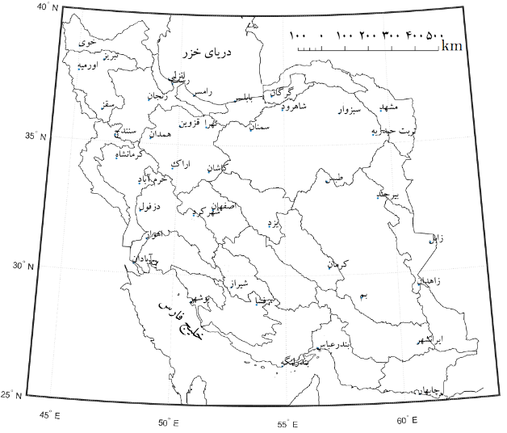 | 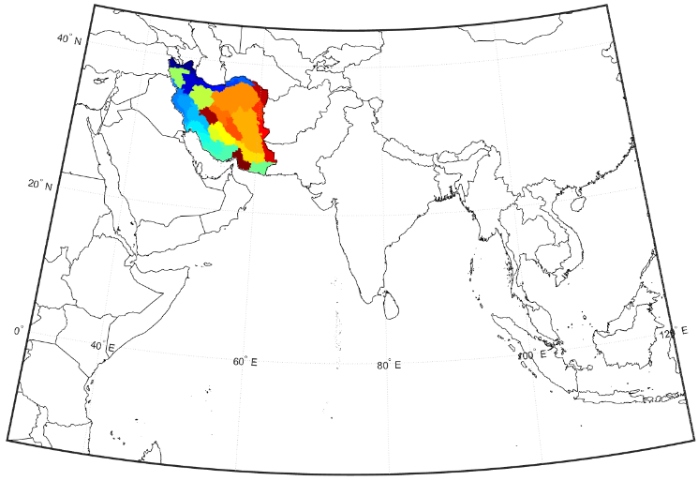
شکل1) 42 ایستگاه همدید برگزیده در این پژوهش | شکل2) موقعیت ایران در چارچوب بُـرد مکانی شبکه IMDAA
برای پر کردن نبودهای آماری سری زمانی دمای ایستگاه‎ها دو روش در پیش گرفتیم. نخست نبودهایی که طول آن‎ها یک روز بود شناسایی و سپس میانگین روز پیش و روز پس از آن را در سری زمانی ایستگاه جاگذاری کردیم. دوم در مورد نبودهایی که طول آن‎ها بیش از یک روز بود میانگین بلند مدت دما برای همان روز تقویمی محاسبه و در سری زمانی ایستگاه جاگذاری شد.
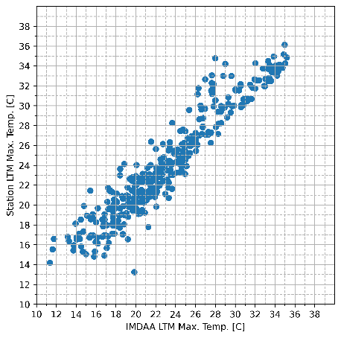 | 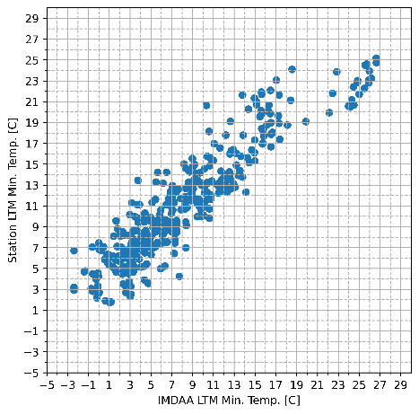
شکل3) پراکنش‎نمای دمای بیشینه داده‎های شبکه‎ای ($IMDAA$) و ایستگاهی | شکل4) پراکنش‎نمای دمای کمینه داده‎های شبکه‎ای ($IMDAA$) و ایستگاهی

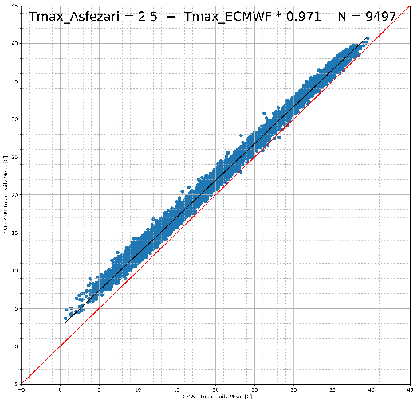 | 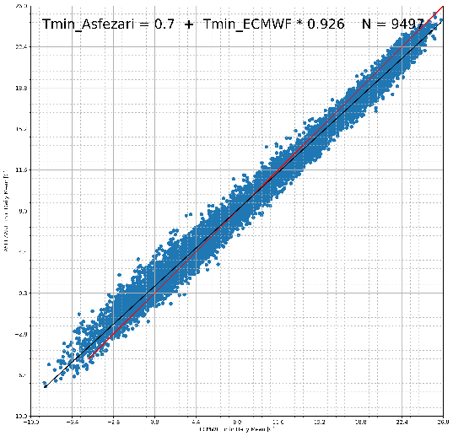
شکل5) پراکنش‎نمای دمای بیشینه داده‎های شبکه‎ای ($ECMWF$) و داده‎های شبکه‎ای اسفزاری | شکل6) پراکنش‎نمای دمای کمینه داده‎های شبکه‎ای ($ECMWF$) و داده‎های شبکه‎ای اسفزاری
هم برای داده‎های ایستگاهی و هم برای داده‎های شبکه‎ای سری زمانی دمای روزانه را به روش زیر به سری زمانی دمای روزانه‎ی هموار شده بر روی یک پنجره‎ی 365 روزه تبدیل کردیم.
(1) | $${\check{T}}_{j}=\frac{1}{365}\sum_{i=j-182}^{j+182}{T_{i}} j=[183,184,…,n-182]$$
در این جا $T_{i}$ دمای روز $i$ ام و ${\check{T}}_{j}$ دمای هموار شده‎ی روز $j$ ام بر روی پنجره‎ی 365 روزه و $n$ تعداد روزهای دیدبانی است.
به این ترتیب چرخه‎های سالانه‎ی دما که چالشی بر سر راه شناسایی گشتگاه‎های ( نقطه‎ی گشت، نقطه‎ی تغییر) چندسالانه در دادهها هستند از سری زمانی پالایش شد. شناسایی گشتگاه‎ها بر روی این سری‎های هموار شده انجام شد.
برای آزمون فرضیه‌ی وجود جهش (نقطه‌ی گشت) در مقابل فرضیه‌ی روند در سری‌های زمانی دمایی ایران، از الگوریتم بهینه‌سازی قطعه‌ای با رویکرد کمینه‌سازی مجموع هزینه‌ها استفاده شده است. اساس این روش بر این اصل استوار است که سری زمانی به بخش‌هایی با ویژگی‌های آماری همگن تقسیم می‌شود و نقاط شکست به گونه‌ای انتخاب می‌شوند که مجموع هزینه‌های درون‌قطعه‌ای کمینه شود. تابع هزینه‌ی به‌کاررفته از نوع مجموع مربعات باقیمانده برای تشخیص تغییرات در میانگین و پراش داده‌ها است که به‌صورت زیر تعریف می‌شود:
(2) | $$C\left(y_{a:b}\right)=\sum_{t=1}^{b}{{\left(y_{t}-\frac{1}{b-a+1}\sum_{i=a}^{b}{y_{i}}\right)}^{2}}$$
در اینجا $y_{a:b}$ نماینده زیردنباله‌ای از سری زمانی از زمان $a$ تا $b$ است. این تابع هزینه به روش بازگشتی نقطه شکست بهینه را می‌یابد. برونداد این الگوریتم، آرایه‌ای از اندیس‌های زمانی است که نماینده نقاط احتمالی جهش در سری زمانی است.
بحث
آب و هواشناسان غالباً به دنبال یافتن روند در داده‎های جوی هستند. گرچه ممکن است گزینه‎ی روند در مقابل گزینه‎ی عدم تغییر انتخاب مناسبی باشد اما ممکن است گزینه‎ی گشتگاه در مقابل گزینه‎ی روند خطی معنادارتر باشد(جـانـدیـالـا، 2014). بنابر این بسیار به جا خواهد بود اگر از خود بپرسیم آیا به راستی دمای کمینه و دمای بیشینه‎ی ایران در طی چند دهه‎ی گذشته روند افزایشی داشته است یا دمای هوا در بازه‎های زمانی مشخصی جهش پیدا کرده است؟ روشن است که چشم‎اندازی که پاسخ این پرسش در برابر ما پدیدار می‎سازد کاملاً متفاوت خواهد بود. اگر سری زمانی دما جهش یافته باشد و کشور را از یک حالت اقلیمی خنک‎تر به یک حالت اقلیمی گرم‎تر منتقل کرده باشد سازگاری با حالت اقلیمی تازه که نماینده‎ی یک دوره‎ی باثبات دمایی اما گرم‎تر است بسیار ساده‎تر خواهد بود تا زمانی که دمای هوا واقعاً دارای روند باشد که در این صورت دوره‎ی باثبات دمایی معنایی ندارد و افزایش روزافزون دما سازگاری با این شرایط دمایی را چالش‎انگیز می‎سازد.
برای پاسخگویی به پرسش بالا سه مدل را برای تبیین رفتار زمانی دما در نظر می‎گیریم. اول مدل میانگین( صفر گشتگاه): در این مدل فرض می‎کنیم میانگین بلندمدت دما بهترین تبیین را از رفتار زمانی دما به دست می‎دهد. دوم مدل تک گشتگاه: در این مدل فرض می‎کنیم سری زمانی دما تا یک لحظه‎ی زمانی معین حول یک میانگین مشخص نوسان می‎کرده و پس از آن میانگین دما تغییر کرده و از آن پس دما حول میانگین تازه نوسان پیدا کرده باشد. سوم مدل روند: در این مدل فرض می‎کنیم رفتار زمانی دما وابستگی خطی به زمان دارد و با گذشته زمان افزایش یا کاهش می‎یابد.
گشتگاه نماینده‎ی تغییر ناگهانی در یک سری زمانی است(امینی خانقاهی و کوک 2016). به زبان ساده می‎توان واکاوی گشتگاه را شناسایی نقاطی از یک مجموعه داده دانست که در آن ویژگی‎های آماری داده‎ها تغییر می‎کند(کیلیک و همکاران 2012). در این پژوهش برای شناسایی گشتگاه تغییر میانگین را مبنا قرار دادیم. به این ترتیب نخست یک نقطه را بر روی سری زمانی برگزیده و سری را به دو بخش تقسیم می‎کنیم. سپس میانگین دما را برای هر بخش، جداگانه محاسبه می‎کنیم. برای هر بخش مجموع انحراف از میانگین را برای همه‎ی نقاط هر بخش محاسبه می‎کنیم. مجموع انحراف از میانگین همه‎ی بخش‎ها را جمع کرده و مانده‎ی کل را به دست می‎آوریم. نقطه‎ی تقسیم را آن قدر جابه‎جا می‎کنیم تا مانده‎ی کل کمینه شود.
گشتگاه‎هایی که در یک سری زمانی آب و هوایی دیده می‎شوند ممکن است به علل غیر آب و هوایی مانند جابه‎جایی ایستگاه اندازه‎گیری رخ داده باشند. مثلاً چنان که رحیم‎زاده و نساجی(1393) نشان داده‎اند دو گشتگاه موجود در سری زمانی دمای شهرکرد ناشی از جابه‎جایی این ایستگاه به محلی با شرایط آب و هوایی متفاوت بوده است. این دو گشتگاه در 21/01/1382 و 16/08/1358 در سری زمانی دمای کمینه‎ی ایستگاه دیده می‎شوند.
برای مقایسه‎ی سه مدل روند، میانگین و تک گشتگاه، آماره‎ی RMSE را برای هر 42 ایستگاه و تحت هر سه فرض را محاسبه و مقایسه کردیم. محاسبات نشان داد که مدل تک گشتگاه رفتار دما را بسیار بهتر از مدل روند و مدل میانگین تبیین می‎کند. برای دمای کمینه در چهل و دو ایستگاه میانگین مقدار RMSE برای مدل روند 82/0 و برای مدل میانگین 13/1 و برای مدل تک گشتگاه 58/0 به دست آمد. مگر در ایستگاه‎های سقز، سنندج و خوی در همه 39 ایستگاه دیگر مدل تک گشتگاه کارآیی بهتری از مدل روند و مدل میانگین نشان داد. برای دمای بیشینه در چهل و دو ایستگاه میانگین مقدار RMSE برای مدل روند 83/0 و برای مدل میانگین 83/0 و برای مدل تک گشتگاه 63/0 به دست آمد. مگر در ایستگاه‎های سقز، اورمیه، قزوین و اراک در همه 38 ایستگاه دیگر مدل تک گشتگاه کارآیی بهتری از مدل روند و مدل میانگین نشان داد.
بررسی گشتگاه دمای بیشینه‎ی 42 ایستگاه همدید روشن ساخت که بهار 1377 در بیشتر ایستگاه‎ها با تغییر معنادار میانگین همراه بوده است(شکل7 و شکل8). ایستگاه‎هایی مانند همدان، کرمانشاه، خرم‎آباد، سبزوار، شهرکرد و زابل به علل غیر آب و هوایی غیر از سال 1377 در زمان‎های دیگر نیز گشتگاه نشان داده‎اند ولی با وجود اثرگذاری علل غیر آب و هوایی در ایستگاه‎هایی مانند آبادان، اهواز، اراك، بندرعباس، اصفهان، مشهد، اورمیه، شیراز و تبریز بهار 1377 همچنان مهم‎ترین گشتگاه این ایستگاه‎ها بوده است. در مورد 24 ایستگاهی که مهم‎ترین گشتگاه آن‎ها اواخر سال 1376 و اوایل سال 1377 بوده تغییر دمای بیشینه بین 5/0 تا 0/2 درجه‎ی سلسیوس بوده است. میانگین جهش دما در این ایستگاه‎ها 1/1 درجه‎ی سلسیوس بوده است. در مورد دمای کمینه، هم تعداد گشتگاه‎ها بیش‎تر است و هم رخداد گشتگاه در ایستگاه‎های مختلف ناهمزمان است. سال 1377 همزمان با یکی از نیرومندترین النینیوهای تاریخ بوده است.
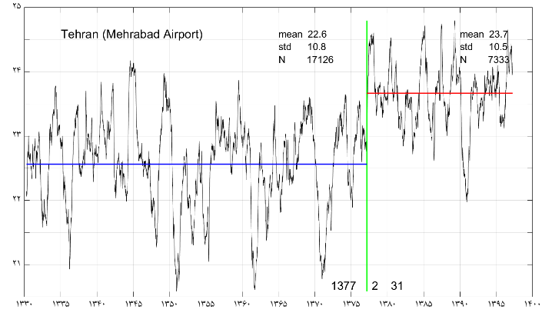 | 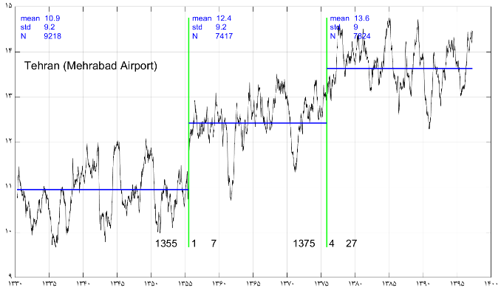
شکل7) جهش در سری زمانی هموار شده (365 روزه) دمای بیشینه در ایستگاه مهرآباد | شکل8) جهش در سری زمانی هموار شده (365 روزه) دمای کمینه در ایستگاه مهرآباد
با توجه به دشواری‎هایی که برای بررسی گشتگاه‎ها با تکیه بر داده‎های ایستگاهی با آن روبرو هستیم به کمک داده‎های شبکه‎ای IMDAA همین واکاوی را به انجام رساندیم. این بررسی نشان داد که در ایران جهش دمای بیشینه ناگهانی و تقریباً همه جا همزمان رخ داده است. بر روی بیش از 90 درصد از گستره‎ی ایران دمای بیشینه در سال 1377 و به ویژه در بهار 1377 جهش پیدا کرده است(شکل9 و شکل10). میانگین بزرگی جهش دمایی 1/1 درجه‎ی سلسیوس بوده اما در نقاط مختلف کشور بزرگی جهش دمایی بین 5/0 تا 0/2 درجه‎ی سلسیوس متفاوت بوده است. این نتایج با آنچه در مورد غالب ایستگاه‎های بررسی شده به دست آورده بودیم سازگار است. همین بررسی را با داده های $ERA5$ هم به انجام رساندیم و نتایج همانندی به دست آمد(شکل11 و شکل12).
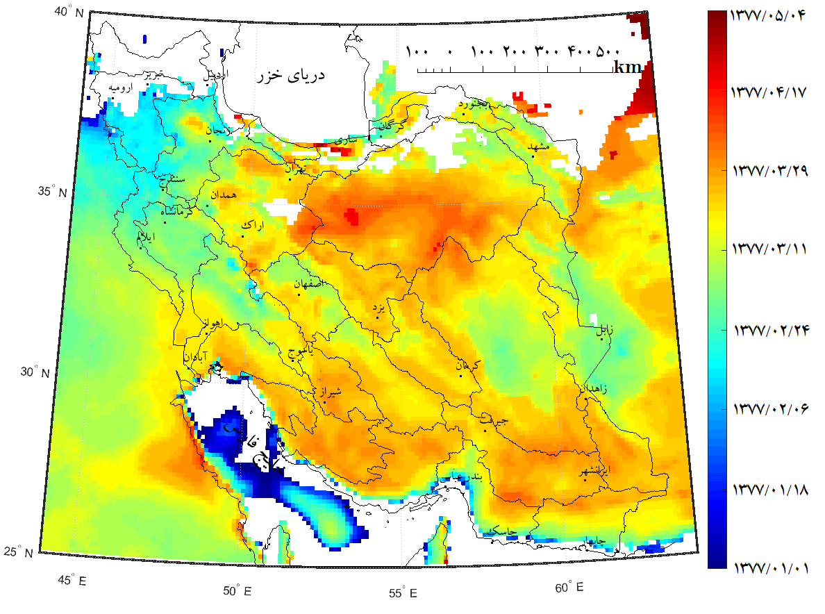 | 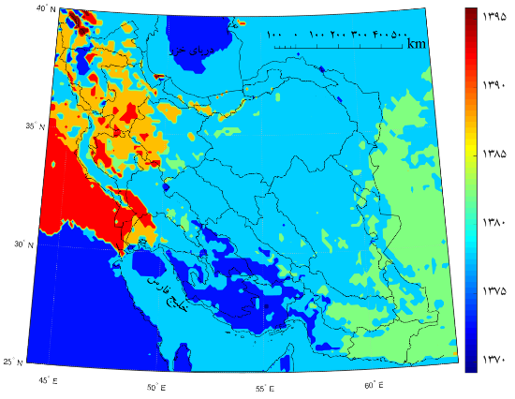
شکل9) زمان رخداد جهش در دمای بیشینه ($IMDAA$) | شکل10) زمان رخداد جهش در دمای کمینه ($IMDAA$)

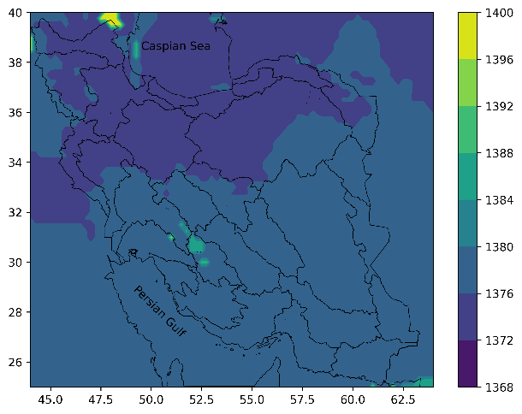 | 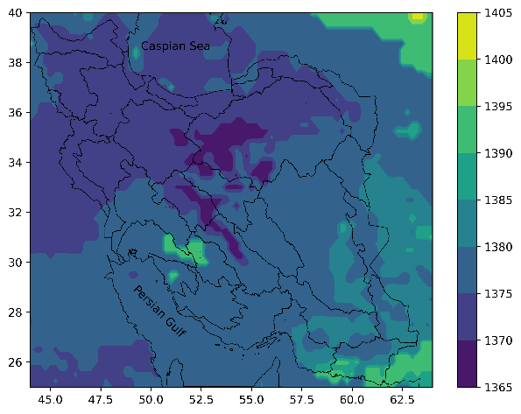
شکل11) زمان رخداد جهش در دمای بیشینه ($ERA5$) | شکل12) زمان رخداد جهش در دمای کمینه ($ERA5$)
در مورد دمای کمینه جهش دما همه جا همزمان رخ نداده است. در یک بازه‎ی زمانی 5 ساله بین سال‎های 1373 تا 1378 حدود 73 درصد از گستره ایران جهش دمای کمینه را تجربه کرده است. میانگین بزرگی جهش دمای کمینه نیز 1/1 درجه‎ی سلسیوس بوده اما در نقاط مختلف کشور بزرگی جهش دمایی بین 3/0 تا 1/2 درجه‎ی سلسیوس متفاوت بوده است.
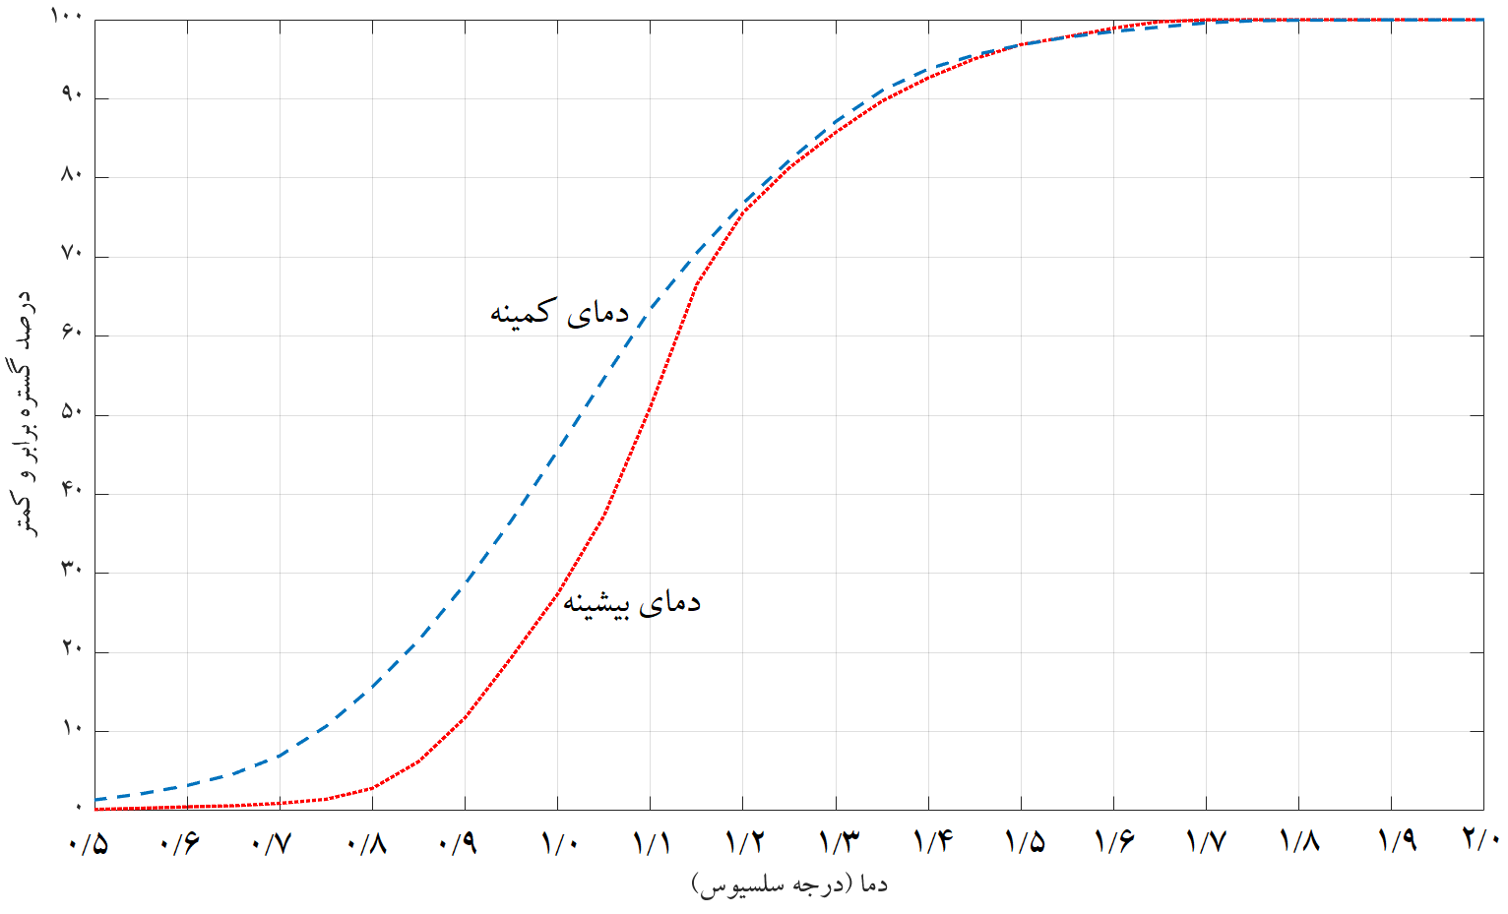
شکل13) پراکندگی بزرگی جهش دما بر روی ایران ($IMDAA$).
بررسی زمان رخداد جهش در داده‎های $IMDAA$ و $ERA5$ نشان داد که اواخر سال 1376 و اوایل سال 1377 یعنی همان سالی که یکی از نیرومندترین النینیوهای سده رخ داده است یک گشتگاه بسیار مهم بوده است هرچند اهمیت آن در دو پایگاه داده یاد شده و برای دمای کمینه و بیشینه یک اندازه نبوده است(شکل‎های 14 تا 17).
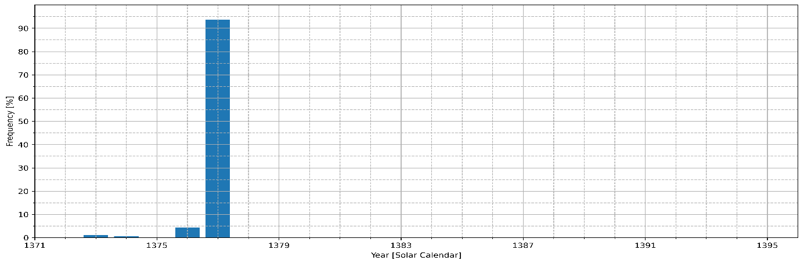
شکل14) توزیع فراوانی زمان رخداد جهش در دمای بیشینه ($IMDAA$)
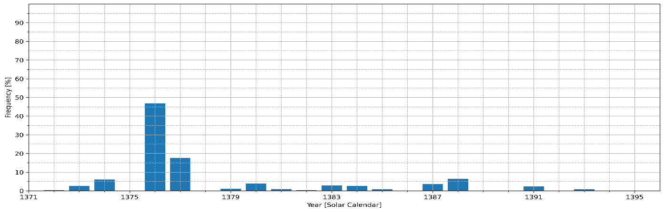
شکل15) توزیع فراوانی زمان رخداد جهش در دمای کمینه ($IMDAA$)
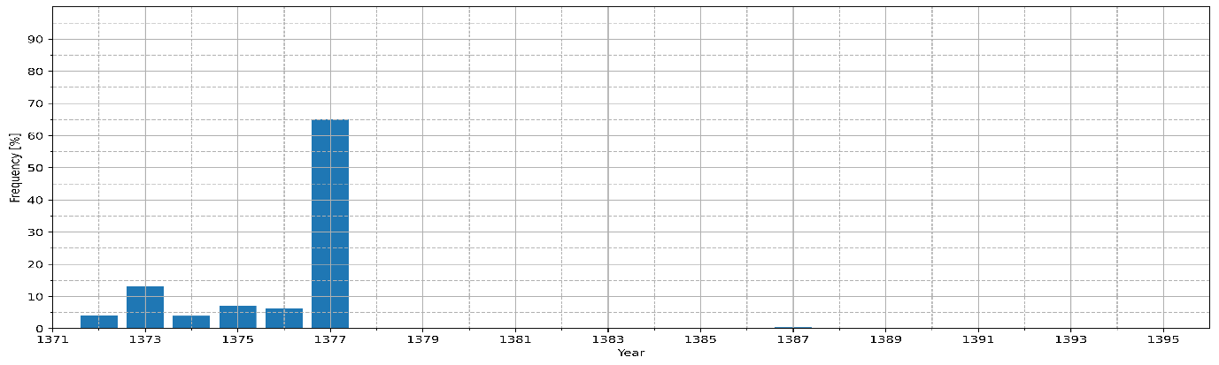
شکل16) توزیع فراوانی زمان رخداد جهش در دمای بیشینه ($ERA5$)
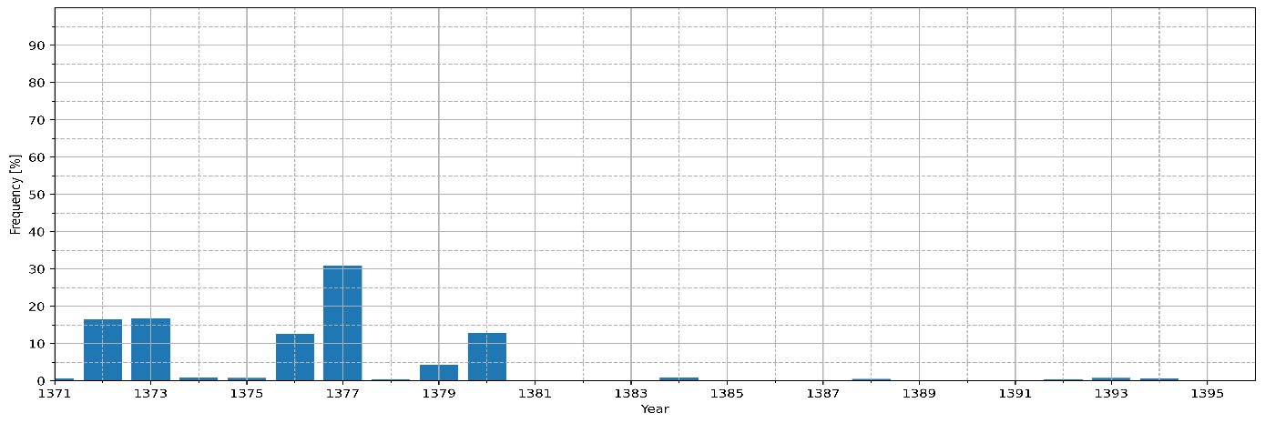
شکل17) توزیع فراوانی زمان رخداد جهش در دمای کمینه ($ERA5$)
دمای هوای سطحی کمیتی است که در نزدیکی سطح زمین اندازهگیری میشود. از این رو طبعاً می تواند از تغییراتی که در نزدیکی سطح زمین رخ میدهد بسیار اثر بپذیرد. گسترش شهرها، جنگلزدایی، بیابانزایی، خشکیدن دریاچهها و عللی از این دست می توانند دمای هوای محل را دگرگون سازند. پس ناروا نخواهد بود اگر جهش دمای ایران در سال 1377 را ناشی از چنین عللی بپنداریم. از سوی دیگر این گمان هم ناروا نیست که جهش دمای ایران ناشی از بازیگران کلانتری باشد که در گسترههای منطقهای یا جهانی کار میکنند. در این صورت دور نیست که جهش دما محدود به سطح زمین نبوده بلکه ستبرای فراخی از هواسپهر را درگیر کرده باشد. برای بررسی این نظر میانگین وزنی هموار شده (پنجره 365 روزه) ستبرای لایه 850-500 هکتوپاسکال بر فراز ایران بررسی شد. بسیار شایان توجه است که سری زمانی ستبرا در 23/02/1377 جهش نشان میدهد(شکل 18).
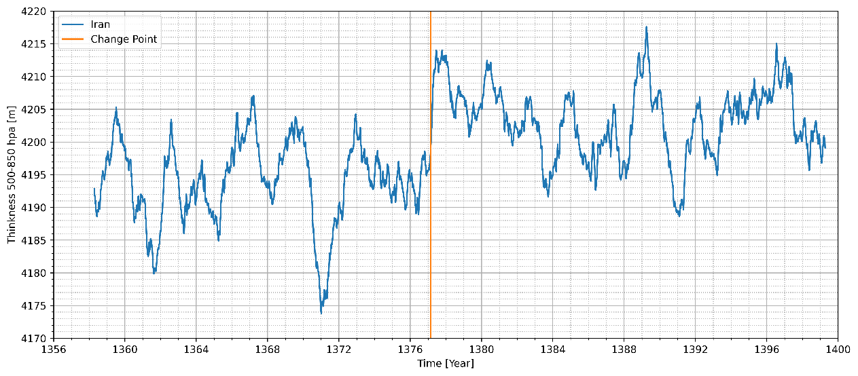
شکل 18) مهمترین جهش در میانگین ستبرای لایه 850-500 هکتوپاسکال بر روی ایران
نتایج
هر چند بسیاری از پژوهشگران ویژگی روند در دمای ایران را گزارش کرده‎اند اما در این بررسی نشان دادیم که ویژگی جهش تبیین بهتری از سری زمانی دمای ایران به دست می‎دهد. داده‎های ایستگاهی با طول دوره آماری بیش از 50 سال از یک سو و داده‎های شبکه‎ای اسفزاری، داده‎های شبکه‎ای $IMDAA$ و داده‎های شبکه‎ای $ERA5$ همگی نشان می‎دهند که سری زمانی دمای ایران به ویژه در مورد دمای بیشینه در سال 1377 دستخوش جهش شده است. از آنجا که سال 1377 همزمان با یکی از نیرومندترین النینیوهای تاریخ بوده است بررسی نقش النینیو و نوسان جنوبی در این جهش‎ها ارزش بررسی بیش‎تر را دارد. دمای کمینه ایران چندین بار و در سال‎های مختلف دستخوش جهش شده است. افزون بر این بزرگی جهش دمای کمینه از دمای بیشینه بزرگ‎تر بوده است. در پژوهش‎های پیشین نیز گرچه فرض وجود روند بررسی شده اما همگی افزایش دمای کمینه را بزرگ‎تر از افزایش دمای بیشینه گزارش کرده‎اند.
تغییراتی که در آب و هوای ایران به ویژه در طی چهار دهه گذشته رخ داده است پیامدهایی برای ایران دارد. بسیاری از چالش‎های کلان کشور با چنین تغییراتی پیوند مستقیم یا غیرمستقیم دارند. تأمین منابع آب آشامیدنی، تأمین منابع آب کشاورزی، تأمین انرژی سرمایش و گرمایش، به مخاطره افتادن حیات وحش گیاهی و جانوری، رشد آفات گیاهی و جانوری، فرونشست در مناطق شهری و فرونشست آبخوان‎ها، به مخاطره افتادن سلامت شهروندان به ویژه کودکان و سالخوردگان و بیماران تنها بخشی از فهرست بلندبالایی است که پیامدهای تغییرات آب و هوایی به شمار می‎آیند. با تغییر آب و هوا همه چیز تغییر می‎کند. تغییر آب و هوا تمدن‎ها را از صفحه روزگار محو می‎کند. آثار آنها را در زیر تلی از خاک و خاکستر پنهان می‎سازد؛ زبان آنها را در تاریکخانه تاریخ مدفون می‎کند و تنها چیزی که یاد آنها را زنده نگه می‎دارد باستانشناسان و زبان‎شناسانی هستند که می‎کوشند از روی آثار به جا مانده زندگی از دست رفته آنها را رمزگشایی کنند. تغییرات آب و هوایی را جدی بگیرید؛ بسیار جدی!

ملاحظات اخلاقی
نویسندگان اصول اخلاقی را در انجام و انتشار این پژوهش علمی رعایت نموده‌اند و این موضوع مورد تأیید همه آنهاست.
تعارض منافع
بنا بر اظهار نویسندگان این مقاله تعارض منافع ندارد.
سپاسگزاری
نویسنده از NCMRWF، وزارت علوم زمین دولت هند برای داده‎های بازکاوی IMDAA سپاسگزاری می‎کند. این داده‎ها با همکاری دفتر هواشناسی بریتانیا، NCMRWF و IMD و با کمک مالی وزارت علوم زمین هند به برنامه طرح ملی موسمی فراهم شده است.

منابع:
ابلاغيان، آناهيتا، علی محمد آخوندعلي، فریدون رادمنش، حیدر زارعي. (1398). بررسي روند تغييرات دما، بارندگي و رطوبت نسبي در ايران.‎ علوم و مهندسی آبیاری، شماره 3، 212-197. https://doi.org/10.22055/jise.2018.17897.1299
انصاری مهابادی، ثمین، حسین دهبان، محمدجواد زارعیان، اشکان فرخ نیا. (1401). بررسی روند تغییرات دما و بارش حوضه‌های آبریز ایران در افق 20 سال آینده بر اساس برونداد مدل‌های CMIP6. پژوهش آب ایران، 16(1)، 24-11.‎ https://doi.org/10.22034/iwrj.2022.11204
بارانی، نادر، آیت الله کرمی. (1398). تحلیل روند سالانه پارامترهای اقلیمی دما و بارش در نواحی ده گانه زراعی-اکولوژیکی ایران. فصلنامه علوم محیطی، 17(4)، 90-75.‎ https://doi.org/10.29252/envs.17.4.75
حلبیان، امیرحسین. (1396). واکاوی روند وردش‌های دمای بیشینه و کمینه در فلات ایران. مطالعات جغرافیایی مناطق خشک، 8(30)، 75-61. https://jargs.hsu.ac.ir/article_161458_62b0059b8929a61703c3835ffc79c967.pdf
‎ حلبیان، امیرحسین، جواد پورشهبازی، محمود سلطانیان. (1396). ارزیابی تغییر دمای بیشینه و کمینه فصلی ایران. مجله آمایش جغرافیایی فضا، 7(23)، 10-1.‎ http:/gps.gu.ac.ir/article_47252_d9d2df00be7483f65350b334f7b67107.pdf
رحیم زاده، فاطمه، مجتبی نساجی زواره. (1393). روند و تغییرپذیری دما در ایران در دوره 2010-1960 پس از تعدیل ناهمگنی های غیرطبیعی موجود در داده ها. تحقیقات جغرافیایی، 29(4)، 196-181.‎ https://georesearch.ir/article-1-332-fa.pdf
عباسی، فاطمه، منصوره کوهی، یاشار فلامرزی، زهره جوانشیری، شراره ملبوسی، ایمان بابائیان. (1398). تحلیل روند میانگین دما و بارش سالانه در ایران برای دوره 1988 تا 2017 میلادی. نیوار، 43(106-107)، 41-55. https://doi.org/10.30467/nivar.2019.184059.1128
عساکره حسین، پیرو لیونلو، سیدحسین میرموسوی، سحر صدرافشاری. (1401). شبیه سازی تغییرات دما در نیمه غربی ایران طی دوره (1960-2100) با استفاده از مدل های واکاوی شده و خروجی مدل های.RCP8.5‎ تحقیقات کاربردی علوم جغرافیایی، شماره 66، 17-1. https://www.sid.ir/fileserver/jf/4002114016601.pdf
علوی نیا، سیدحسن، مهدی زارعی. (1400). آنالیز روند تغییر اقلیم با استفاده از شاخص های حدی داده های بلند مدت بارش و دما در جنوب شرق ایران‎. فصلنامه علمی برنامه ریزی منطقه ای، 11(44)، 119-134.‎ https://doi.org/10.30495/jzpm.2022.4059
علی پور، یوسف، ناصر بیات، علی اصانلو. (1401). آشکارسازی و تحلیل روند دمای ایران در تراز 1000 هکتوپاسکال. فصلنامه علمی-پژوهشی اطلاعات جغرافیایی «سپهر»، 31(121)، 203-191. https://doi.org/10.22131/sepehr.2022.252778‎
علیجانی، بهلول، احمد روشنی، فاطمه پرک، روح الله حیدری. (1391). روند تغییرپذیری فرین های دما با استفاده از شاخص های تغییر اقلیم در ایران. جغرافیا و مخاطرات محیطی، شماره 2، 28-17. https://doi.org/10.22067/geo.v1i2.18617
کیخسروی کیانی، محمدصادق؛ سیدابوالفضل مسعودیان. (1399). واکاوی روند تغییرات آغاز فصل انباشت پوشش برف در ایران با بهره‌گیری از داده‌های سنجش از دور. جغرافیا و برنامه ریزی محیطی، 31(1)، 14-1.‎ https://doi.org/10.22108/gep.2020.120775.1249
کیخسروی کیانی، محمدصادق؛ سیدابوالفضل مسعودیان. (1396). واکاوی روند تغییرات روزهای برفپوشان در ایران بر پایۀ داده‌های دورسنجی. جغرافیا و برنامه ریزی محیطی، 28(1)، 60-49.‎ https://dor.isc.ac/dor/20.1001.1.20085362.1396.28.1.5.8
مسعودیان، سیدابوالفضل، محمد دارند. (1394). بررسی روند تعداد روزهای یخبندان ایران. نشریه جغرافیا و توسعه، 13(39)، 60-49.‎ https://doi.org/10.22111/gdij.2015.2004
مسعودیان، سیدابوالفضل، محمد دارند. (1391). تحلیل زمانی-مکانی روند روزهای فرین سرد ایران. تحقیقات جغرافیایی، 27، 56-37.
https://jgr.ui.ac.ir/article_17930_b9c46e317c98790ee499fc1b20c63eb6.pdf
مسعودیان، سیدابوالفضل(1398) بازتاب تغییرات محیطی در تغییرات توزیع فراوانی دمای رویه ی زمین: مطالعه موردی حوضه زاینده رود و حوضه اورمیه. مخاطرات محیط طبیعی، شماره 19، ص 275-264. https://doi.org/10.22111/jneh.2019.28272.1485
منتظری، مجید؛ سیدابوالفضل مسعودیان. (1392). تقویم دمای روزهنگام ایران. نشریه جغرافیا و توسعه، 11(31)، 14-1.‎ https://doi.org/10.22111/gdij.2013.790

Aminikhanghahi, S., Cook, D.J. (2017). A survey of methods for time series change point detection. Knowledge and information systems, 51(2), 339-367.
Cahill, N., Rahmstorf, S., & Parnell, A. C. (2015). Change points of global temperature. Environmental Research Letters, 10(8), 084002.
Hersbach, H., Bell, B., Berrisford, P., Hirahara, S., Horányi, A., Muñoz‐Sabater, J., ... & Thépaut, J. N. (2020). The ERA5 global reanalysis. Quarterly journal of the royal meteorological society, 146(730), 1999-2049. https://rmets.onlinelibrary.wiley.com/doi/epdf/10.1002/qj.3803
Jandhyala, V. K., Liu, P., Fotopoulos, S. B., & MacNeill, I. B. (2014). Change-point analysis of polar zone radiosonde temperature data. Journal of Applied Meteorology and Climatology, 53(3), 694-714.
Killick, R., Fearnhead, P., & Eckley, I. A. (2012). Optimal detection of change points with a linear computational cost. Journal of the American Statistical Association, 107(500), 1590-1598.
Rani, S. I., Arulalan, T., George, J. P., Rajagopal, E. N., Renshaw, R., Maycock, A., ... & Rajeevan, M. (2021). IMDAA: High-resolution satellite-era reanalysis for the Indian monsoon region. Journal of Climate, 34(12), 5109-5133. https://journals.ametsoc.org/downloadpdf/view/journals/clim/34/12/JCLI-D-20-0412.1.pdf

Rani
Hersbach
Jandyala
Killick

